Bridgend transitional foster carer policy

First version: March 2021

Document Name and Location: Transitional Foster Carer Policy

Author: Alex Fitzpatrick, Team Manager Placements
Y Gyfarwyddiaeth Gwasanaethau Cymdeithasol a Lles, Social Services and Wellbeing Directorate
Cyngor Bwrdeistref Sirol Penybont ar Ogwr, Bridgend County Borough Council
Ffôn / Phone: (01656) 642367
E-bost / Email: Alex.Fitzpatrick@bridgend.gov.uk
Gwefan / Website: www.bridgend.gov.uk

Document Owner: Laura Kinsey
Pennaeth Gofal Cymdeithasol, Blant l Head of Children’s Social Care
Cyngor Bwrdeistref Sirol Penybont ar Ogwr, Bridgend County Borough Council
Ffôn / Phone: (01656) 642314
E-bost / Email: Laura.kinsey@bridgend.gov.uk
Gwefan / Website: www.bridgend.gov.uk

Review Date: This document is to be reviewed a minimum of every 3 years after its approval date, the next review to occur no later than December 2023. Incremental reviews may take place as required.
Accessibility: This document is available in Welsh.

Updates, Revisions and Amendments

Version

Details of Change

Date

Contents
1. Introduction: 1
2. Legal and Regulatory Framework: 1
3. Roles and Responsibilities: 2
3.1 Transitional foster carers 2
3.2 Supervising Social Worker 2
3.3 Child’s Social Worker 3
4. Skills and Competencies 4
5. Placement Meetings: 5
5.1 Placement Review Meetings must include: 6
6. Training and Support 6
6.1 Training 7
6.2 Matching 7
6.3 Respite 8
6.4 Support Services 8
7. Payments 10
Appendix 1 11

1. Introduction:
Introduced as part of the residential remodelling programme, we have established a specialist in-house foster caring service, to enable children within the looked after population to transition to a permanent placement. The role of the transitional carer is an integral part of the ‘no wrong door model’, which is underpinned by the trauma informed practice model, adopted within Bridgend County Borough Council placement and provider services. To achieve the desired outcomes, part of the approach is to ‘step down’ children from residential placements to a family living environment, which will include the implementation or continuation of the intensive support package. Integral to the scheme is the level of increased access to support services, which will continue to be offered post transition.
The Transitional Carer scheme will offer placements to children and young people who have experienced trauma, resulting in a variety of complex needs and challenging behaviours, that require a carer who has the ability and level of required competencies and experience to work as part of a team, to assist the child to gain a sense of understanding, enabling emotional regulation.
The children and young people placed through this service will have a variety of experiences such as experiences of abuse and neglect, multiple placement breakdowns, emotional and relationship difficulties, witnessing domestic violence, bereavement, for example which may have led to, challenging behaviour, difficulties with learning and education, offending behaviour, attachment issues and an inability to regulate emotions.
Placements will be made for up to 24 weeks, but may be extended for a further period in line with the needs of the young person. During this time the carer will build a one-to-one relationship with the young person, showing commitment, patience and dedication to help them, applying behavioural strategies to reduce the behaviours which may have led to the breakdown of placements in the past.
The overall aim of the Transitional Carer scheme will be to move the young person on into a successful, long-term placement that aligns with their needs and enables them to reach their full potential. This could be a move into a long-term fostering placement, returning to birth family or a supported independent living environment.

2. Legal and Regulatory Framework:
The Transitional Foster Care scheme is operated in accordance with all relevant legislation, regulations and guidance, and incorporates the requirements and expectations of the following:
- The Local Authority Fostering Services (Wales) Regulations 2018
- The foster panels (Establishment and Functions) (Wales) Regulations 2018
- Social services and Well-being Act Wales (2014), Part 6 code of practice (Looked After and Accommodated Children)

3. Roles and Responsibilities:

3.1 Transitional foster carers
Transitional Foster Carers are required to provide a therapeutic fostering placement to a young person aged 0-18 years old for a maximum period of 24 – 36 weeks with the aim of developing a supportive relationship to enable the young person to move onto a long term foster placement and/or return to birth family. Carers will need to develop relationships with children/young people using trauma informed therapeutic parenting and support children/young people to overcome barriers that may have led to the breakdown of placements.

As part of the multi-agency team, carers will need to provide detailed recordings about a child/young person’s progress share all relevant information with social workers and other professionals involved and work in accordance with the child/young persons’ care plan in order to achieve positive outcomes. To do these carers will need to attend and contribute to meetings that are held in relation to a child in their care.
A critical part of the role is for carers to be able to support the child/young person to understand and develop their identity and to identify coping mechanisms to support them through transition. Children and young people who are placed with Transitional Carers will have complex needs and it is essential for a carer to be available for them at all times of the day.
Relationships amongst transitional carers are central to the service and providing respite and short breaks to other carers and supporting each other carers will often be able to overcome problems before they escalate or lead to placement breakdown and increase protective factors around children.

3.2 Supervising Social Worker
In accordance with the Local Authority Fostering Services (Wales) Regulations 2018, it is a requirement that that the local authority must ensure that foster carers are appropriately supervised. Given the impact of trauma on the children who will be placed with transitional foster carers, supervision will be provided on a fortnightly basis when there is a child placement. Where there is no child in placement, supervision will be undertaken on a monthly basis. The supervision will identify the carer’s learning and developmental needs and support the foster carer to access the resources to meet these needs. This may include delivery of one to one sessions within supervision, directing the carer as to where they may access appropriate reading or research, formal training or peer support from foster carer’s. The focus of discussion within supervision will vary according to the presenting needs within the placement.
Additional contact will be made between supervision via telephone calls or home visits. The frequency of contacts will be agreed between the supervisor and the foster carer and will be adjusted in accordance with the presenting needs of the carer and/or young person.
The supervising social worker is responsible for undertaking appropriate matching and placement planning with foster carers, with the support of senior social workers within the fostering service. This may include but not limited to:

  - Ensuring the foster carer has been provided with all the relevant information prior to agreeing to young person being placed.
  - Coordinating a placement-planning meeting with the child’s social worker or appropriate representative from the social work team and the carer.
  - Working with the child’s social worker to coordinate a package of support for the placement.
  - Coordinating placement review meetings, which will take place a minimum of fortnightly with the child’s social worker and monthly with all agencies supporting the child, including education where appropriate.
  - Chairing and keeping appropriate records of placement planning and review meetings.

The supervising social worker will link with the Behavioural analyst to arrange regular joint/individual sessions in relation to continuation of ‘development of behavioural strategies’ and support regarding ‘trauma informed parenting’.

The supervising social worker may need to attend Accommodation and Permanence Panel (APP) with the social worker for the child to support the care planning process.

3.3 Child’s Social Worker
The worker for the child will retain the same responsibilities for children placed in transitional care to other children who are looked after with regard to assessments and statutory visits.

In addition, the social worker for the child must assist in the arrangement of and attend fortnightly placement review meetings. There may be occasions where the child’s social worker will be unable to attend an arranged meeting and on those occasions, it is their responsibility to ensure that suitable cover from the team is arranged.

The child’s social worker must agree the frequency of contact outside of meetings, reviews and statutory visits with the carer and supervising social worker. It is the expectation that a child in transitional care will be the subject of a multiagency plan of support, which will outline contact between the child, their carer and the agencies involved with supporting the placement.

The child’s social worker will need to present the child’s case to APP to seek specific interventions to support the child and/or carer as determined by assessments; this may include regular respite provision.

The child’s social worker with the support of senior staff in their team will agree the child’s care and transition plan. The transitional carer, supervising social worker and any additional workers involved need to contribute to the plan via completion of recordings, attendance at meetings, attending reviews and providing feedback on request.

4. Skills and Competencies
As a transitional foster carer, it is an expectation that you can demonstrate that you are able to meet the core fostering competencies 1-4 (CORAM BAAF section E) (as set out in Table 1 below). Carer’s competency will be evidenced as part of the assessment and approval process, and where required, further support will be provided to enable carers to demonstrate their ability to be considered as a transitional carer. The qualities we would wish to see are set out in Table 2 below.

TABLE 1
Coram BAAF Prospective carers Fostering assessment form F – competency matrix (section E)
1. Caring for children
1.1 Ability to provide a good standard of care to children which promotes healthy emotional, physical, sexual and intellectual development
1.2 An ability to accept the individual child
1.3 An ability to provide care appropriate to the individual child as he/she is
1.4 An ability to work closely with children’s families and others who are important to the child
1.5 An ability to set appropriate boundaries, and manage children’s behaviour within these, without the use of physical or other inappropriate behaviour
1.6 A knowledge of normal child development and an ability to listen to and communicate with children appropriate to their emotional age and understanding
1.7 An ability to promote a young person’s development towards adult status
2. Providing a safe and caring environment
2.1 An ability to ensure that children are cared for in a home where they are safe from harm or abuse
2.2 An ability to help children keep themselves safe from harm or abuse, and to know how to seek help if their safety is threatened
2.3 An ability to recognise the particular vulnerability to abuse and to discrimination of disabled children
3. Working as part of a team
3.1 An ability to collaborate with other professional workers and to contribute to the department’s planning for the child/young person
3.2 An ability to communicate effectively
3.3 An ability to keep information confidential
3.4 An ability to promote equality, diversity and rights of individuals and groups within society
4. Own development
4.1 An ability to appreciate how personal experiences have affected themselves and their families, and the impact that fostering is likely to have on them all
4.2 An ability to use people and links within the community to provide support
4.3 An ability to use training opportunities and improve skills
4.4 An ability to sustain positive relationships and maintain effective functioning through periods of stress

TABLE 2
Additional qualities required to demonstrate level of understanding and ability in relation to the role of transitional carers

5. Transitional Care
5.1 An ability to promote a positive relationship between the young person and their personal advisor and/ or social worker.
5.2 A knowledge of the impact of trauma on child development and emotional wellbeing
5.3 Understanding of attachment and its impact on the behaviour and emotional development of young people.
5.4 Ability to apply PACE parenting techniques

5. Placement Meetings:
Once the matching process has been completed and a placement with a transitional carer agreed, a placement-planning meeting must take place. The supervising social worker and child’s social worker should agree who needs to attend at this meeting.

At a minimum, the meeting must include the child/young person (where appropriate), child’s social worker, transitional carer and supervising social worker. Consideration may be given as to whether the child or young person only attends part of the meeting depending on the circumstances. It may be appropriate for a previous foster carer or representative from the child’s current placement to attend, or any other worker involved who may be providing support to the placement.

The placement-planning meeting must include:

- A plan of introductions for the child/young person to the carer and placement.
- The behaviour analyst will attend planning meeting as directed.
- A discussion of the child/young person’s needs and any specific expectations on the carer regarding how these are to be met, such as transport to therapy sessions, how contact is to be facilitated, meeting any specialist medical needs for example.
- Agreeing the outcomes to be achieved over the duration of the placement that will be the subject of review meetings thereafter.
- Discussion of the package of support to the placement including the frequency of contact by workers involved in supporting the placement or any respite requirements.
- Agreement of who will be invited to review meetings.
- An opportunity for any questions or discussion of any other issues that are deemed relevant by those in attendance.

It is envisaged that placements with transitional carers will be made as part of an overall care plan. However, there may be occasions where a child or young person may be placed on an emergency basis. In such instances, a placement-planning meeting should take place at the earliest opportunity following the child being placed but no more than one week after the placement.

The support package for children placed in a Transitional Foster Care Placement will require attendance at Accommodation and Permanence Panel for agreement, for example if there is a need for regular respite, specific therapeutic support or specialist service to be commissioned from an independent agency. This should also be considered at the placement-planning meeting.

5.1 Placement Review Meetings must include:
Following the Placement Planning Meeting and in order to ensure that a child’s needs continue to be met, a Placement Review Meeting will be held every two weeks thereafter. During this meeting, the following matters will be considered:

- An update on the progress of the placement from the previous meeting.
- A discussion of any significant incidents and review of any agreed actions.
- A review of the outcomes identified to be met, agreeing who is undertaking what piece of work and setting of milestones to measure success.
- Any adjustments that need to be made to the support package or frequency of contact.
- Setting of any actions and timescales to be achieved.

6. Training and Support
Part 10 of the Local Authority Fostering Services (Wales) Regulations 2018 states that:

- The local authority provider must ensure that foster parents have the information they need to provide care and support to a child placed with them in accordance with the child’s care and support plan.

- The local authority provider must ensure foster parents receive such training, advice and support, including support outside office hours, as appears necessary in the interests of children placed with the foster parents and to enable them to provide care and support to children in accordance with each child’s care and support plan.

- The local authority provider must ensure prospective foster parents receive such training, information and advice as is considered necessary.

6.1 Training
In order to both meet the needs of children placed in Transitional Care and the requirements of legislation; it is an expectation that transitional foster carers complete the 6 identified mandatory core training courses as identified by the National Fostering Framework and complete Tier 1 and 2 of the training matrix (appendix 1). The fostering team has a duty to make arrangements for the provision of this training within 28 days of approval. Transitional carer’s are also required to attend Tier 3 training within 18 months post approval (see appendix 2).
All Bridgend County Borough Council foster carers are required undertake a minimum of 2 formal training sessions or equivalent each year. This can include, but is not limited to, reading research, undertaking self-directed learning using online resources, (such as the open university), listening to webinars or podcasts, informal learning within supervision or via placement support worker (or equivalent) and learning from watching a TV programme. Such activities can be used as evidence of learning and development where there is evidence that the carer has reflected on the learning and considered how it may be applied in practice.
It is an expectation that learning and development is discussed within supervision, not only reflecting on what has been learned and how it may be applied, but also identifying any additional learning needs of the carer. This may include training to meet a specific need for the child/young person in placement, such as Dyadic Developmental Psychotherapy (DDP). Given the complexity of the children who will be placed within transitional care it is of upmost importance that transitional carers are supported to maintain and develop their skills.
If expectations in relation to learning and development are not met, the supervising social worker would seek to come to an agreement with the transitional carer, in the form of an action plan to address learning and developmental needs with clear timescales for completion. In the event that agreement cannot be reached or actions are not completed this will be addressed via completion of an annual review to consider whether a change of approval is required.

6.2 Matching

Every care is taken to ensure that children and young people are matched to the right placement. Within transitional care, as outlined above, the expectation is that each placement will be provided with a support package tailored to the specific needs of the placement, which will be subject to regular review. There are instances where carers may feel they do not have the skills and experience to meet the individual needs of a child, which may lead them to decline a placement. However if the local authority feels there is clear evidence of an appropriately matched child/young person being identified and the carer declines placements on several occasions, the matter will be referred to panel via annual review to consider whether the carer has the appropriate skills and experience required for transitional foster care.

6.3 Respite
It is reasonable for a transitional carer to expect there to be a respite break between transitional placements due to the intense nature of the support provided. The local authority would seek to ensure at least a 2-week respite period between transitional placements unless there are exceptional circumstances, such as an emergency placement being required. Provision of respite and support to other transitional carers would not be included in this.
It is also reasonable for a transitional carer to take planned holidays. As with general foster carers, transitional carers will be encouraged to include children and young people in holidays. However due to the short-term nature of the placements this may not always be achievable.
There may be times where additional respite is required due to a child’s needs and the carer needing a short break or for holidays that have been pre-booked prior to a child being placed with them. In the first instance, this should be discussed with the supervising social worker to ascertain the reason and duration and who will be responsible for ensuring appropriate arrangements are made. In the instances where a transitional carer has a vacancy or potential availability, they will be approached to provide the respite in the first instance as a transitional carer would be the best match for a child residing in a transitional foster care placement. If respite is required and there are no transitional, carers available to support then a referral will need to be made through the supervising social worker to Bridgend Foster Care Service.

6.4 Support Services
Therapeutic Support
Where a child has therapy needs identified, the child’s social worker can apply to APP for agreement of funding for therapeutic needs to be met.

Behavioural Analyst
Behaviour Analysis and the development of Positive Behaviour Support Plans plays a key role in Bridgend County Borough Council’s Placement Service. Where a child/young person is stepping down from Maple Tree House Assessment Unit, following a Complex Assessment, the Behaviour Analyst will work with the wider Team to develop a Transition Plan in line with the needs of the individual child.

The Behaviour Analyst will also be able to provide consultation to Transitional Foster Cares and their Supervising Social Workers to enable the development of individual positive behaviour management strategies.

Placement support worker
In line with all other foster carers for Bridgend County Borough Council, transitional carers will be able to access a Placement Support Worker (PSW) and/or Re-unification Worker where it is considered necessary to support the placement.

The PSW will undertake individual sessions with the foster carer/s which may include: 1:1 training as well as practical advice and support whilst the re-unification workers will undertake direct work with children and their carers to achieve the outcomes identified within Care and Support Plans. The supervising social worker makes referrals to the PSW and the re-unification workers.

Liaison Carers
Transitional Foster Carers can access liaison carers who are experienced foster carers available to provide guidance with queries, concerns and emotional support. The Liaison Carers run regular coffee mornings so that you can link in with other foster carers and provide support to one another. Liaison Carers are also on hand to support you to attend meetings with the team, or if you experience an allegation.

Vocational Outreach Workers
In addition to the support available to all foster carers in Bridgend, the transitional carers will also be able to access support from the Vocational Outreach workers who are based within Maple Tree House who will offer skill development, learning opportunities and activities to young people on an individual and group basis who are struggling to settle in mainstream educational provisions. Vocational Outreach workers will make use of the outdoor environment and other facilities to make a real difference to young people’s lives and help their journey to find the best within themselves, to assist them to unlock their potential, raise their self-esteem and prepare them to face their future with confidence. Vocational Outreach workers will be available to support placements during evenings and weekends where the need is identified.

Peer Support
It is good practice for a transitional carer with a vacancy, to contact the other transitional carers to share that they are available for support if needed, this may be but is not limited to practical support in terms of looking after a young person for a foster carer to attend an appointment or training, or could be emotional support and reassurance.

Maple Tree House (hub)
During Out of Hours only, Transitional carers are able to contact the senior residential worker on duty for advice. The senior residential worker will give due consideration to all requests to include urgent transport requests, support in dealing with a crisis situation and emergency outreach worker requests to assist with a crisis situation. Emergency intervention, requiring an emergency placement will be given consideration, but will determined by bed availability and matching of other young people placed within Maple Tree House at the time of the request.

The Emergency Duty Team (EDT) are a dedicated team who are on-hand to provide out of hours support for emergencies, they are available after office hours and at weekends.

7. Payments
Transitional carers will receive an allowance whether or not they have a child in placement in order to retain transitional foster carers and in recognition of the expectations that transitional carers have:
- The skills required to support complex placements.
- A willingness to provide support to their peers and provide respite placements.
When a child is in placement the transitional carer will also receive the age related fostering allowance for that child.
Where a child is matched to a transitional carer, payments can commence at the point a transition plan to the placement is agreed. This will enable the foster carer to be available for suitable introductions to be made as part of a therapeutically informed transition plan.
The complex needs of the children placed with transitional carers may necessitate provision of regular respite support. As with general foster carers, where this is deemed to be an appropriate, agreement should be sought via Accommodation and Permanence Panel (APP) by the Social Worker for both the child and the foster carer, for payments to continue to the substantive carer over the respite period.
Foster carers are encouraged to take children and young people in placement on holidays where possible. As with general foster carers, where a transitional carer has a planned holiday and the young person is not able to attend, requiring an alternative placement, payments in respect of the child will not be made, unless there are exceptional circumstances agreed via APP or a Group Manager.

Appendix 1

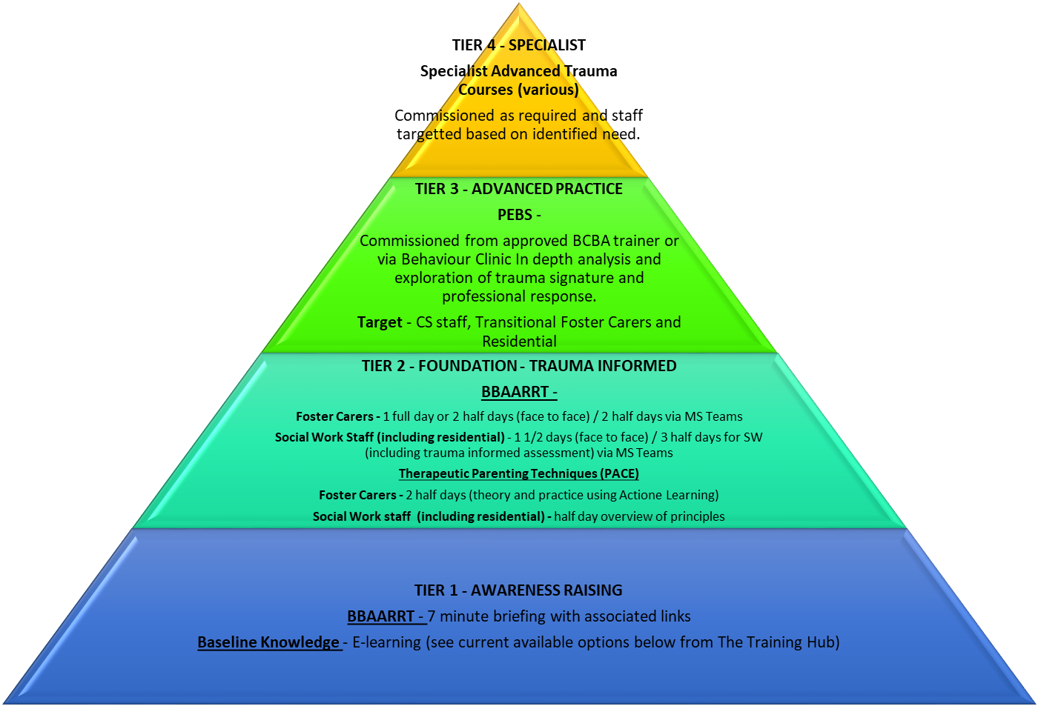

Training Pyramid for Working with Trauma – see below for baseline knowledge requirements in relation to Foster Carer (Including Transition Carers) and the broader fostering training plan incorporating the above elements.

