Re
Bridgend County Borough Council

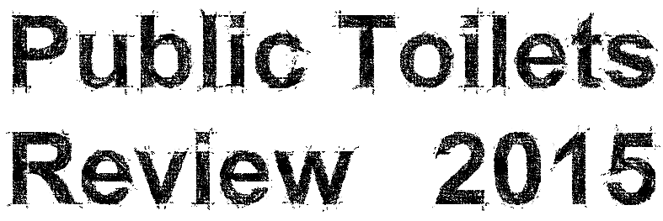

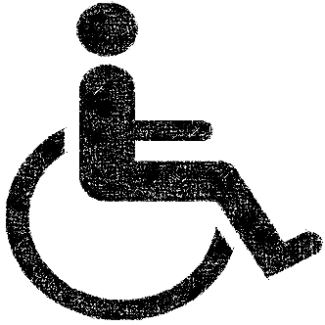

Date of issue: 12 January 2015
Action required: Responses by 9 March 2015

Tel: (01656) 643 664
Email: consultation@bridgend.gov.uk
Web: www.bridgend.gov.uk/consultation

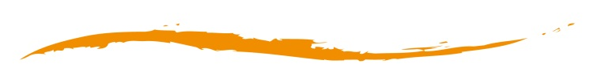

www.bridgend.gov.uk
Contents
Overview 3
How to respond 3
Data protection 3
Related documents 3
Background and information 4
Impact of the proposal 6
The consultation process 6
How to respond 7
Appendix 8

Overview
Bridgend County Borough Council invites you to share your views on the 13 council owned public toilets in the county borough and how the council can make the best use of the resources available.

How to respond
This consultation period will begin on the 12 January 2015 and close on the 9 March 2015.
You can respond or ask further questions in the following ways:
Tel: (01656) 643 664
Email: Consultation@bridgend.gov.uk
Online: Click here or visit: www.bridgend.gov.uk/Consultation
Post: Communications, Marketing and Engagement,
Bridgend County Borough Council, Raven’s Court, Wing 3, Brewery Lane, Bridgend, CF31 4AP.
Alternative formats are also available upon request.

Data protection
How we use the views and information you share with us.
All responses received by Bridgend County Borough Council will be seen in full by its staff members involved in the consultation process. The information may also be seen by other departments within the council or local service board members to help improve upon the services provided.
The council may also use the information gathered to publish subsequent documents both directly and indirectly linked to this consultation, however the council will never disclose any personal information such as names or addresses that could identify an individual.
If you do not wish for your opinions to be publicised, please state so in your response.

Related documents
For more information on consultations in Bridgend County Borough or how to join our Citizens’ Panel.
Visit: www.bridgend.gov.uk/Consultation
www.bridgend.gov.uk/CitizensPanel

Background and information
As part of the council’s response to central Government cuts in the funding provided, Bridgend County Borough Council is reviewing the services it provides to make the best use of the resources available.
The council is currently responsible for 13 public toilets across the county borough. These facilities include eight locations which are staffed during open hours, and five locations which are visited and cleaned on a routine basis.
An overview of the 13 public toilets has been included below. The star rating system follows: one star – poor, two stars – fair, three stars – good. Facilities cover disabled access and baby changing unit availability.

Bridgend Toilet Facilities
Location | Condition | Accessibility | Comments
Bus Station

Derwen Road |  |  | Building has major structural issues which would be expensive to repair.
Rhiw Hill |  |  | Location poorly lit.
Cheapside (opposite Asda superstore)

Maesteg Toilet Facilities
Location | Condition | Accessibility | Comments
Bus Station

Porthcawl Toilet Facilities
Location | Condition | Accessibility | Comments
John Street |  |  | Grade two listed building
Pavilion - basement level

Griffin Park

Rest Bay

Other Facilities
Location | Condition | Accessibility | Comments
Aberkenfig
Blackmill
Kenfig National Nature Reserve
Pricetown Square

Comfort Scheme
Until March 2014, Bridgend County Borough Council ran a public facilities scheme which was funded by the Welsh Government. This was branded as the ‘Comfort Scheme’ within the County Borough. It worked by making small grants of up to £500 per year available to businesses which would allow the public to access their toilet facilities. The users did not need to be customers of the business and the grant helped with the businesses costs. Regrettably this scheme is no longer directly funded by Welsh Government and it was discontinued from April this year.

Council’s budget consultation results 2014
In November, the council consulted with its residents regarding the proposed budget cuts from central Government. As part of the consultation 34 per cent of respondents supported a review of the current public toilet facilities.

Impact of the proposal
An initial Equality Impact Assessment (EIA) screening will be completed ready for when the consultation is live and will be reviewed following conclusion of this consultation (appendix 1.0).

The consultation process
Projected timetable for procedure and proposal implementation
Activity | Date
Response deadline | 9 March 2015
Report to Cabinet on the outcomes of the consultation | 18 March 2015
Potential implementation | 1 April 2015

The outcomes of the consultation (which will be incorporated into the proposal to the report where possible) will be reported to the Cabinet of Bridgend County Borough Council. If there is a decision not to proceed, that will be the end of this proposal and an alternative proposal may be sought.
If any of the proposals are accepted by Cabinet the earliest the change(s) will come into effect is 1 April 2015.
How to respond
This consultation period will begin on the 12 January 2015 and close on the 9 March 2015. You can respond or ask further questions in the following ways:
Post: Communications, Marketing and Engagement,  Bridgend County Borough Council,  Raven’s Court, Wing 3,  Brewery Lane, Bridgend, CF31 4AP | Tel: (01656) 643 664  Email: Consultation@bridgend.gov.uk  Online: Click here
Alternative formats are also available upon request.

Appendix
Appendix 1.0 - Equality Impact Assessments (EIA).
Initial screening.
Full EIA to be completed after 2 March 2015.

