APPENDIX A

BRIDGEND COUNTY BOROUGH COUNCIL

PUBLIC CONSULTATION REPORT

REPORT OF THE CORPORATE DIRECTOR – EDUCATION AND TRANSFORMATION

SCHOOL MODERNISATION PROGRAMME: Outcome of Consultation on Proposal to make a regulated alteration in the form of an enlargement to Brynmenyn Primary School and relocate it into a new building on surplus land adjacent to Coleg Cymunedol Y Dderwen

1 Purpose of report

1.1 This report is to inform the outcome of the consultation on the proposal to make a regulated alteration in the form of an enlargement to Brynmenyn Primary School and relocate it into a new building on surplus land adjacent to Coleg Cymunedol Y Dderwen.

- Connection to Corporate Plan / Other Corporate Priorities

  - The school modernisation programme supports many of the corporate priorities and in particular:

- Working Together To Raise Ambitions And Drive Up Educational Achievement

  - We aim to help all young people to thrive and make the best of their talents. As part of this, there is a serious need to modernise our schools.

- Background

3.1 In September 2006, the Council adopted a policy of providing continuity of education from ages 3 to 11 where possible. On 3rd March 2015, Cabinet approval was received for the Council to adopt revised principles as a framework for school organisation in Bridgend; five key principles were set out to inform the organisation and modernisation of our schools:

- Commitment to high standards and excellence in provision.
- Equality of opportunity, so that all pupils can access quality learning opportunities, regardless of which school they attend.
- Inclusive schools, which cater for the learning needs of all their pupils.
- Community focussed schools, where the school actively engages with its local community.
- Value for money.

3.2 The Policy and Planning Framework sets out 17 areas where these principles should be applied in practice.

3.3 The principles which are particularly relevant in the context of this proposal concern the size of primary schools (to ensure that “all Bridgend’s primary schools are large enough to make the full range of necessary provision”) and value for money, efficiency and effectiveness and the provision of local schools, planning new provision to reflect changes in the distribution of the population.

  - There is growing pressure on the number of school places in the Valleys Gateway Area of the County Borough due to recent, current and planned housing developments in the area. The three primary schools serving the Valleys Gateway area are:

- Brynmenyn Primary School
- Bryncethin Primary School
- Tondu Primary School

  - The relocation and enlargement of Brynmenyn Primary is considered to be the preferred means available to the Council in order to address growing pressure on the number of school places in the Valleys Gateway Area.

  - The relocation and enlargement, should it go ahead, would also require changes to the existing catchments of the three schools to take the pressure off both Bryncethin Primary and Tondu Primary. Consultation on catchment area changes would be undertaken as a separate exercise and would not affect those pupils already attending either of those primary schools. This would mean that Bryncethin Primary could continue as it currently is with 235 places 4-11 plus nursery and Tondu Primary could be brought together on one site, as a one form entry school.

  - This report outlines the responses to the consultation and seeks approval to continue the process to the next stage.

- Current situation

  - In order to progress the proposal, consultation exercises were carried out between 23rd March 2015 and 5th May 2015 with staff, governors, parents, pupils and also the wider community in accordance with the statutory School Organisation Code. A copy of the consultation document was also made available during this time on the Councils website:

http://www1.bridgend.gov.uk/services/consultation/hub/brynmenyn-consultation.aspx

  - The consultation document invited views and opinions to be submitted in respect of the proposal to open the school in September 2017.

  - Following receipt of advice from technical officers, the construction programme for the proposed new build is such that the school would be ready for occupation on 1st January 2018, which is a change to the proposed opening date. The views of the school governing body have been sought with this regard and the Chair, although disappointed in the modified opening date, accepts the alternative timescale.

  - Under the statutory Code referred to above, the Council is required to publish a consultation report summarising any issues raised by consultees and including its own response and setting out Estyn’s view of the overall merit of the proposals.

  - If approved by Cabinet, the next stage of the process is to publish a statutory notice outlining the proposals which would need to be published for a period of 28 days and any formal written objections would be invited during this time.

  - If there are no objections during the Public Notice period then Cabinet can consider whether to determine the proposal.

  - If there are objections at this Public Notice stage, an objections report will be published summarising the objections and the Council’s response to those objections. Cabinet will need to consider the proposal in light of objections. Cabinet could then accept, reject or modify the proposal.

Summary of responses to consultation

4.8 Key points from the consultation exercises were as follows, with full details appended to this report.

4.9 Pupil consultation

The Brynmenyn Primary School Council met with BCBC Council representatives on 30th May 2015 to discuss the proposal. Subsequent to discussions and a question and answer session (detailed at Appendix i), pupils were asked to raise their hands if they thought the amalgamation was a good idea; all pupils raised their hands bar one.

  - BCBC Council representatives met with the Tondu Primary School Council on 30th May 2015 to discuss the proposal. Subsequent to discussions and a question and answer session (detailed at Appendix i), pupils were asked to raise their hands if they thought the amalgamation was a good idea. A Show of hands was taken to see what the children thought of the proposed change; everybody present thought it was a good idea.

4.11 BCBC Council representatives met with the Bryncethin Primary School Council on 30th May 2015 to discuss the proposal. Subsequent to discussions and a question and answer session (detailed at Appendix i), pupils were asked to raise their hands if they thought the proposal was a good idea; everybody thought it was not a good idea to locate a primary next to a comprehensive site.

Parent, community and interested party consultation
4.12 A consultation “drop in” session to discuss the proposal with Council representatives for parents, carers, members of the local community and all other interested parties was held on 30th April 2015. No parents, carers, members of the local community or any other interested parties attended (see Appendix ii).

Governing body and School staff consultation

4.13 A consultation meeting was held with Brynmenyn Primary Staff and Governors on Monday 27th April 2015. Questions were raised concerning potential staffing impacts of the proposal and future pupil to staff ratios. Council representatives explained that the local authority has previously worked with staff and governor regarding a smooth transition. (Full details of the meeting discussions and responses/clarifications given are detailed in Appendix iii).

4.14 A consultation meeting was held with the Bryncethin Primary School Staff and Governors on Wednesday 29th April 2015. The main concerns expressed centred around issues of job security for staff. Council representatives explained that, as the other school (the relocated Brynmenyn Primary) grows if there are any individuals at risk we would look to safeguarding those jobs in areas where teachers and support staff are needed. Any feedback will be incorporated into a Consultation Report which will be going to Cabinet on 16th June. Cabinet can decide to amend or approve the draft report. Stakeholders will be informed of the outcome of the consultation. If the proposal is agreed a Public Notice will be published and will run for 28 days. This is an opportunity for people to object to the proposal. If there are objections, an Objection Report will go to Cabinet in September and they will decide if to go ahead with the proposal. (Full details of the meeting discussions and responses/clarifications are detailed in Appendix iv).

4.15 A consultation meeting was held with Tondu Primary Staff and Governors on Wednesday 22nd April 2015. The main concerns expressed related to issues regarding the impact of the proposal on staffing structures. (Full details of the meeting discussions and responses/clarifications given are detailed in Appendix v).

Summary of written representations

4.16 One item of direct correspondence was received during the consultation period expressing concerns regarding highway issues surrounding the proposed site (see Appendix vi).

4.17 A response was sent to the originator of the correspondence thanking them for their submission and stating that their comments would be taken into consideration in the report submitted to Cabinet.

4.18 Three responses to the consultation were received via the BCBC website online survey facility. The comments were as follows:

- If children are already attending Tondu Primary School but live closer to the proposed new site will they be forced to move? (Authority response – No).
- “I would like to fully support the proposal to move Brynmenyn School to a new purpose built facility adjoining CCYD. I am an ex pupil and I was a governor at Brynmenyn for over 25 years. The school, over the past few years, has developed and become very popular and successful with numbers growing year on year. The nursery was oversubscribed every year but we were restricted as to what numbers we could take into the reception class. Our PAN being only 22. The school has changed very little since my school days in the late 1950's. Prefab classes were erected just after the war as a temporary provision but are still in use today. If you visit the school you will see that it is now too”.
- “I would welcome the move to a new school site. At present the pupils have no green outdoor space and the classroom is well utilised but very limited. I feel a larger school that is better fit for purpose would benefit both staff and pupils”.

The view of Estyn, her Majesty’s Inspectors of Education and Training in Wales

4.19 Estyn has considered the educational aspects of the proposal (see Appendix vii) and has commented as follows on the information provided:

Summary
4.20 The local authority’s proposal arises from the pressing need to provide more school places within the Valleys Gateway Area, and to reduce pressure for places upon two other ‘gateway’ schools. This proposal is consistent with the local authority’s strategy for school re-organisation.

4.21 It is Estyn’s opinion that this proposal will help increase the number of school places available, and benefit pupils at Brynmenyn through the provision of a modern, and less crowded teaching and learning environment.

4.22 The proposal generally sets out well the rationale for the proposed action and the advantages and disadvantages arising. However, these are not laid out clearly enough to easily assess them or identify the overall weighting of the proposal.

4.23 The overall impact of the proposal on pupil performance data is difficult to assess. The proposal clearly states that there is currently an adverse impact on pupils and staff arising from the overcrowding at the school. However, it only outlines the advantages that would arise from a larger school building. The proposal does not explain clearly the expected improvements that better teaching and learning space may have on the curriculum, on pupil performance, or on provision for more vulnerable pupils including children with Special Educational Needs.

The Local Authority Response
It is expected that the improvements to the school will impact positively on standards with regard to outcomes and wellbeing. The inclusion of a library will improve opportunities for more literacy interventions across the curriculum; improved outdoor provision will provide wider experiences particularly for children in the Foundation Phase. It will assist with literacy, numeracy interventions and helps to increase children’s knowledge of the world and increase their confidence. Increased classroom space in line with pupil numbers will remove the issues associated with overcrowding and will allow sufficient room for children to move about as appropriate learning activities. Family learning facilities will impact positively on the learning experiences, teaching, care support and guidance provided to assist with vulnerable groups.

4.24 However, the most recent Estyn inspection report and monitoring report both indicate that standards at the school, along with leadership and management are improving, and therefore a change to a new and larger school should at least maintain standards should the proposal go ahead.

- Equality Impact Assessment.

  - An Equality Impact Assessment has been carried out as part of the consultation stage and has been further informed by responses to the consultation papers. The assessment has concluded that there is no negative impact on the duties of the Council towards protected groups. (Appendix ix)

5.2 A Welsh Impact Assessment has been carried out as part of the consultation. It is considered that the proposal would have no impact on the Welsh language provision currently experienced by pupils. (Appendix x)

  - A Community Impact Assessment has been carried out as part of the consultation. The authority will work with the governing body and school to support them in determining a staffing structure and will also encourage and support the primary school in developing community use of the buildings. (Appendix xi)

6 Financial Implications

6.1 The anticipated cost of the new school will be met from the Welsh Government’s 21st Century Schools Programme, for which we have had approval in principle, and the Council’s capital programme as approved initially by Council in February 2012. We will progress the necessary business case procedures in line with Welsh Government requirements during the development and design stages.

7 Statutory process in determining proposals

Provisional timetable:

Report to Cabinet on the outcomes of the consultation (16th June 2015)
Publish Consultation Report on BCBC website, hard copies of the report will be available on request (23rd June 2015)
If agreed by the Cabinet of Bridgend County Borough Council, a Public Notice will be published (24th June 2015) and there will be a period of 28 days in which to submit any objections to the proposal in writing
End of Public Notice period (22nd July 2015)
If there are no objections Cabinet can decide whether to proceed or not. If there are any objections, an Objections Report will be forwarded to Cabinet for their consideration and subsequent determination and subsequently published (9th September 2015)

Hard Copies of this report are available on request from:
Ellen Franks
c/o Corporate Director – Education and Transformation
Children’s Directorate,
Civic Offices
Angel Street
Bridgend
CF31 4WB

Telephone number: (01656) 642617

Or by e-mail from: ellen.franks@bridgend.gov.uk

Appendix i

Brynmenyn Primary Consultation
30 May 2015 Brynmenyn , Tondu, Bryncethin Primary’s
In Attendance:
Brynmenyn Primary School Council
Gaynor Thomas- Senior Project Manager
Sarah Lee- Project Manager

1 | An overview was given explaining how catchments work and about the proposal to make a regulated alteration in the form of an enlargement to Brynmenyn Primary School and relocate it into a new building on surplus land adjacent to Coleg Cymunedol Y Dderwen. Questions were invited and these are minuted below:
1.1 | - When will the school be finished? The school would be finished in 2017; however we are not in the design phase yet. Those of you that will be in the primary during the design phase will be involved in the design process and you can give your views.  - Will there be any stairs like at Pen Y Fai? Yes the building will probably be two storey build with the ground floor for the infants and the junior children upstairs.  - Will there be fencing dividing the comprehensive from the Primary? Yes.  - Will the school have a library? There may be an area for the library in the ‘street’ which is a wide corridor with designated zones e.g. for ICT, creative investigatory work and the library.  At this point the head teacher expresses the desire to have a designated library room because the school has not had one before. They would like it named after Sarah Jayne Howell, the school heroine.  - How many classrooms will there be? The school is a 2 FE school which means 14 classes (2 for each year) plus nursery rooms.  - Will toilets be separate to the cloakroom? They will be the same standardised design as Pen-y-Fai  - Will the yard be accessible? The nursery and infant children will most likely have direct access to the yard. The juniors would come down the stars to outside areas.  - Will there be disabled provision if the building is 2 storeys? Yes there will be 1 or 2 lifts to the upper floor. There will also be disabled parking spaces in the carpark and the site is flat. We will need to segregate pedestrians from traffic.  - Will there be changing rooms for PE? Possibly- we need to be mindful of funding. When we look at the floor area during the design phase, every m² has a value attached to it so we need to look at the size of the floor and outer ground area as well as accounting for additional costs such as paying fees for designers and engineers and then furnishing the building.  - How many yards will there be? There will be dedicated, infant, nursery and junior yards.  - Where will delivery drop offs go? There will be a service delivery yard so that there is no contact with children.  - Will there be fire exits? Yes and the travel distance which is the distance you have to walk to the exits will meet legislation. You will also have a sprinkler system in the building  - Will PE be in the hall and separate to the dining room? You will have a main hall and a studio hall.  - Will there be a safe route to get to the school? Our colleagues in highways look at the way children get to school. The school is close to a cycle path so this may be a possible route.  - Will there be a 1st aid room? You will have a sick bay near the office and a medical inspection room.  - Which road will trucks come in from? The road next to the caretaker’s bungalow is the probable entry point. This will bypass the comprehensive school and straight through to the primary school  - Will there be an ICT room? There will most likely be an ICT area dedicated in the ‘street’ space  - Will there be bike racks to encourage pupils to cycle? In Brackla they have them away from the carpark, with a cover. Yes they will probably be located at the front of the school  - When will building start? 2016  - Will there be football and rugby fields? Yes, but it is not known whether the pitch will be all weather or grass as yet.  - Will there be storage for footballs? Yes there will be a place to store outdoor play equipment and each classroom will have its own storage cupboard  - Will there be sheltered outdoor areas? There will be some covered areas but where they will be is not known yet.  - Will there be a bigger carpark? Yes because the school will be bigger and there will be more staff than at present.  - Will there be water fountains? Yes, drinking water will be available  - Will there be CCTV? Yes, both outside and inside the school. Also on the perimeter for vulnerable areas and at the main entrance.  - Will there be fobs? There will be a push button or fob as a secure access method from reception to the school teaching area. Only staff will have fobs.  - Will there be banking? No the site is flat  - Will there be nurture rooms and choir room? Room allocation is for the head teacher to decide.  - Will there be a visitor’s book? Yes as well as drop off spaces  - Will there be a nap room? No but there will be a quiet room for the infants  - Will there be a staff room? Yes there will be a separate staff room  - Will there be drink storage? This depends on the budget but there will be fridges  - Will we have more technology than now? There has been no decision made but there will be ICT equipment. This is a decision for the local authority and the school to make  - Will the staff remain the same? The school and staff will remain the same but it will be bigger and have more staff  - If there is a school catchment change, what does this mean? Children that currently go to the school can attend the new one. Anyone that currently attends and has a little brother or sister- they may be able to attend the school. Then a decision on who can attend is based on the distance that children live from the school.  - Do we have to reapply for the school? No, the school would be the same just becoming larger and relocating.  - Will there be a garden connected to the school? Yes and we will work with the school to decide how we will segregate areas out.
1.2 | A Show of hands was taken to see what the children thought of the change. Everybody bar 1 thought that it was a good idea.

Brynmenyn Primary Consultation
30 May 2015 Brynmenyn , Tondu, Bryncethin Primary’s
In Attendance:
Tondu School Council
Gaynor Thomas- Senior Project Manager
Sarah Lee- Project Manager

1 | An overview was given explaining how catchments work and about the proposal to make a regulated alteration in the form of an enlargement to Brynmenyn Primary School and relocate it into a new building on surplus land adjacent to Coleg Cymunedol Y Dderwen. Questions were invited and these are minuted below:
1.1 | - What will the catchment look like? We do not know what the catchment will look like yet but all of the Pandy site would close and all pupils would attend the site in Meadow Street.  - What will happen to Aberkenfig if a big school is built? Catchments are still being explored by the Childrens Directorate and so we don’t know where the catchment boundaries will be as yet. I would have thought that Aberkenfig children would still attend Tondu Primary School as they so now.  - How big will the school be? It will be a 420 Primary school plus 60 Nursery. This means that it will be 2 form entry and have 14 classes plus 2 nursery classes.  - Will there be new resources? The project would be funded by Welsh Government and from the capital programme. As the school would have more space for pupils more children will be attending and therefore they will need more resources.  - Do we have to change schools? No you do not have to move schools  - Can we have money to develop the outdoors from the sale of the Pandy site because we will need to make allowances to bring more children over to this site? We will take this back to our colleagues and look into it.  - Can we choose to move school? You and your parents can choose if they wish you to change schools  - Why can’t Tondu have the extra children? The problem with the Tondu site is the access into the school. The size of the site is large but highways will not allow development as it will cost over £1 million to put a road into the site. From an ecological view, woodland would need to be taken down and protected species and wildlife would be disturbed. Also, Brynmenyn is more central to the area.  - Will the carpark be bigger? Yes because the school is being enlarged and there will be more staff
1.2 | A Show of hands was taken to see what the children thought of the change. Everybody thought it was a good idea.

Brynmenyn Primary Consultation
30 May 2015 Brynmenyn , Tondu, Bryncethin Primary’s
In Attendance:
Bryncethin School Council
Gaynor Thomas- Senior Project Manager
Sarah Lee- Project Manager

1 | An overview was given explaining how catchments work and about the proposal to make a regulated alteration in the form of an enlargement to Brynmenyn Primary School and relocate it into a new building on surplus land adjacent to Coleg Cymunedol Y Dderwen. Questions were invited and these are minuted below:
1.1 | - Why don’t you spend money on the NHS rather than this school because there are lots of schools already? There are a lot of schools but there will be housing developments taking place and we need to make enough space for the additional children as a result of these developments. Brynmenyn is too small for its current numbers.  - Will the older children have an effect on the younger children? There will be a school car park and playing fields between the schools as well as a boundary fence so we do not think so.  - If 6th formers are taking drugs and smoking, will this interfere with the Nursery? Well carers/parents will physically be taking their children into the school which will prevent 6th formers from contacting nursery children. There is a carpark and a playing fields between the two school and it may be that we stagger the starting times of the primary and the comprehensive school  - The main road outside the comprehensive site is already very busy and if there are more children at the site this will increase traffic. Young children may try crossing the road to get to the park. We have done a traffic assessment to see what the impact is on the roads and will be working with our highways colleagues to put traffic calming and control measures in. It may be that we stagger the start and end times of the school days.  - I am concerned with fighting and other bad behaviour that may take place at the comprehensive. Little children may see and copy. This is down to the management of the school and we will raise this with our Director of Education  - How is a new school going to improve the quality of Childrens education? It should do - research has shown that both attainment and grades increase from giving teachers the right space, equipment and resources to teach. There will be the correct size rooms; More up-to-date resource such as ICT equipment. A sustainable building helps children learn about environmental issues. There are more opportunities for smaller groups to the taken out of class to get extra support. Children will also have direct access to outdoor space such as playing fields that they do not have at the moment. There will be gardening opportunities and access to the outdoors for the foundations phase such as for soft play.  - I do not think it should be built on the comprehensive site because some students use bad language and this may impact on the smaller children. Children will be supervised on their breaks. We will look at the timings of the school day.  - If parent park over the road will this not be a safety issue? Guardians/Parents should have control of their children, especially when crossing the road. We will ensure the school site is safety features e.g. CCTV, suitable fencing.  - Are pupils happy with the move? Pupils and staff of Brynmenyn are. Moving the school makes it more central to Brynmenyn catchment so it will be easier to get to for more people. We are yet to find out parents views.  - What are the advantages? There are not sufficient numbers of places for children in the area and a new build will remove overcrowding. It will also mean that there are a better standard of facilities. There is currently a backlog on maintenance of the current building.  - I think the move is a positive thing because there is too much traffic outside the current Brynmenyn School.  - What will happen to the old Brynmenyn site? This is unknown until cabinet make a decision as to whether Brynmenyn will move.  - Will the carpark be bigger? Yes. Our highways team will make as much parent drop places onsite as possible  - Will the Lorries and diggers be dangerous when the school is being built? When contractors come to build a school we say when they can and cannot deliver to site. We will tell them to do no vehicle movement at the start and the end of the day to make sure the area is safe.  - I am worried that big children may hang out on the primary site and trash it. The site will be secure and will have internal and external CCTV to help prevent this  - What are the potential disadvantages? This depends on people’s views; some parents may prefer to send their children to a smaller school but some may prefer a larger school. Larger schools have more money to spend on the curriculum and resources. Another perceived disadvantage may be that it will be located next to a secondary school.  - Will the building work not distract children? The old Ynysawdre School was built directly next to Coleg Cymunedol Y Dderwen School. We will work with the secondary school to locate exams away from the building work to minimise noise.  - What size is the school? 420 primary plus 60 nursery children so there will be 14 classrooms and 2 Nursery rooms. There will be a street that can create extended spaces for activities such as science, art, craft and Investigatory work.  - How much are you planning on spending? £ 8.7 million which covers Design work, building work, survey work as well as paying for a range of engineers etc. IT, furniture and equipment will be included.  - How much did Coleg Cymunedol Y Dderwen cost? £39 million  - What happened if this school is not built? We will need temporary mobile classrooms at the current schools.  - What happens if parents disagree? Cabinet will decide whether to proceed and if not we will need to think how we can meet the demand for places as a result of the projected increase in pupil numbers.  - Will the bungalow at Coleg Cymnedol Y Dderwen be demolished? No – this will remain for the caretaker.  - I think a new school should be built because the current rooms are too small at Brynmenyn but build it on a different open space. The land next to Brynmenyn is common land so we cannot build there. The current Brynmenyn site is not big enough and there is nowhere to put children in the meantime. Tondu Primary was looked at but the access to the site is too small. The comprehensive was the preferred site.  - Why not build an extra part to Brynmenyn elsewhere? It is easier to have all children under one roof rather than being on a split site.
1.2 | A Show of hands was taken to see what the children thought of the change. Everybody thought it was not a good idea to locate a primary next to a comprehensive site.

Appendix ii

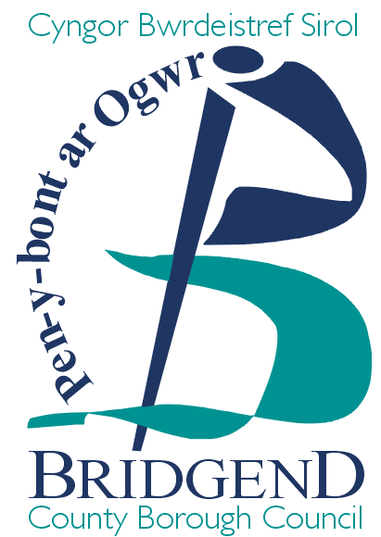
Brynmenyn Primary Consultation Drop in Session with Parents / Interested Parties
Thursday 30th April 2015

Present: Nicola Echanis, Head of Strategy Partnerships and Commissioning
Gaynor Thomas, Senior Project Manager, Property Section
No parents / interested parties attended the meeting.

Appendix iii

Brynmenyn Primary Consultation Meeting with Staff and Governors
Monday 27th April 2015

Present: Robin Davies, Group Manager, Business Strategy and Performance
Alison Gwyther, Senior Advisor, Human Resources
Gaynor Thomas, Senior Project Manager, Property Section
Clare Dale, Headteacher
5 members of staff and governing body

Robin Davies introduced the consultation session and set out the purpose of the meeting, nature and process of the consultation and outlined the proposal.

Questions/Issues | Answer/Comments
From our point of view we have read the consultation document and are well aware of reasoning behind it. It is a no brainer, we have to do it. My one, not even a concern, it’s more a consideration, is how fast we expand? Will we move with the numbers as they are, will numbers expand on a yearly basis? We are concerned how we manage the growth and speed of the growth. With the new catchment there will be different socially deprived areas to consider. At the moment there is such a good ethos in the school. The concern is how fast we grow, we don’t want to grow too fast and don’t want to lose the ethos. | On the day of opening the new school, September 2017, it will be a two form entry, 420 school.
How would somebody go about applying to the school, would it be the same as the year before or six months before? | Yes it would be exactly the same. It depends if a child is in catchment or not. If they are within the catchment they will be eligible to admit to the school. It is parental choice. If they are not within catchment they will not get school transport.
Will the school be able to take 420 pupils straight away if the school is already up and running? Where are these pupils coming from? | There are new developments within the area. We don’t expect all the children to come from the new housing developments on day one and for the school to immediately be at capacity.
Is there a financial exchange for a bigger school? | We have pupil projections up to 2022 currently and what the projections say, taking into consideration all the housing developments in the area, is that we need a two form entry school. The school will get paid per pupil, via the funding formula. The school should have enough teachers for those pupils. There will be incremental growth for the increased demand. At first the school may not occupy all the teaching spaces.  As we approach 2017, we will have a better idea of the likely numbers for day one.
On 1st September 2017, say there are 300 pupils, how do we prepare for extra teachers on that day? | Twice yearly the finances would be amended - January PLASC and September estimate. There shouldn’t be a position whereby you have a number of pupils more than a staffing allocation. It will take a number of years to develop the school to its maximum capacity.  The authority will work closely with the headteacher to address any issues in terms of staffing the local authority will assist.
So in September 2017 there will be 8 classes for year groups. We are currently over PAN for year 4. There are straight year groups for every class. We are in a deficit budget position this year for the first time in 5 years due to the current economic climate. We have made cuts across the school, not staffing but cuts pulled from other places. Next year we don’t want to be looking for staff cuts and don’t want to lose any skilled staff if we need to replace staff in 6 – 8 month time. | This is a question for the Director to respond regarding the sustainability for the staffing growth in the school. RD provided some assurances but agreed to take back and pick up with the Corporate Director and return the answer to the question.  AG explained the local authority has previously worked with staff and governor regarding a smooth transition. The last thing we want to do is lose staff.
On paper it may look as if the school we are over-staffed at the moment. | It is the same in a number of our schools. In the new school there will be space for a single class structure.
That is a big concern. | Yes, we understand your concern.
The rest is just excitement. | We are pleased.
There have been rumblings in the community. The building has a history and we would like to take some of the history with us. This is the biggest concern with the community. | In terms of identity, it is an important issue particularly in a community school. In the past we have allowed important items or features of the old school to be taken to new locations.
Sarah Jane Howells is part of the school and the noticeboard would have to go to the new school. | Familiarisation and links are important for pupils and staff.
Initially pupils were dead against the new school and then we started to drip feed them. The School Council have a list of questions. | It is critical pupils have a voice and can express themselves.
Is it a done deal or what happens if there are objections? | The consultation period closes on 5th May, we then report back to Cabinet on views and responses that have come in. We present a report to Cabinet on 16th June and after the meeting If they agreed to proceed, a Consultation report is published and available on the BCBC website. On 24th June a Public Notice is issued and will be live for 28 days. Members of the public can object within that period. A Cabinet report is produced on the determination of the notice in September 2015. A project team has been set up and they are meeting tomorrow.
When people object what happens? | It is up to Cabinet to decide if an objection is received. It is easier if people object with a reason.
The transition for pupils from nursery to comprehensive school will be much easier when you are in the one area. | Yes.
In terms of potential objections, we are only aware of the Facebook page which has died a death. None of the page said how it would affect the children. It was just about the building. People misread the consultation and then dropped out of the objection.
There is nothing else, just get on and build us a new school!
We are assuming everything goes smoothly and it is approved. | We are waiting for the finalised programme off the technical officers. Surveys have been completed under the feasibility study. The first project meeting is taking place tomorrow and will give details of the programme. The start on site is February 2016 and this may have slipped. We have been working on the standardized design and should be straight forward.
What happens if the school is not ready in September 2017 and there are 400 pupils? | If there is an increased demand we would have to put in mobile classrooms to accommodation the additional pupils, not here but elsewhere.
There is obviously a contingency built into that? | I would hope so. We do use the SEWSCAP framework in collaboration with 10 other authorities and are within a standstill period at the moment. The contractor will already be known to us. There are 6 lots and will know what lot the scheme is under shortly.  I should imagine it will be a 2 storey school; very much like Penyfai.  Some of the outdoor facilities will be shared. There will be a 10,000 sq metre grass pitch at the school. Y Dderwen has an all-weather and 3G pitch next door and the school may be able to use those facilities.
Away from the school talking about the catchment changes what are these? | It would be a separate consultation. At the moment we are working through a methodology trying to apply to all our schools. The catchment boundary will need to change to reflect the changes in the locality. We are working through the process. The main focus of the population will need to be in the new school. The catchment consultation will not be until later in the year.
At the moment we have 50 – 70% of pupils out of catchment. | We will need to look at a lot of different variables.
There are a lot of odd catchment area e.g. Bryn Road – odds and evens. | We need to review our catchment areas.  At the moment the school transport policy is under review and will be going to Cabinet in June. The proposal is to change the statutory distance from 1.5 miles to 2 miles for primary aged pupils.
If you are changing the catchments you have to be careful. | In some schools catchment children have transport as there is no safe route to their school. We don’t transport out of catchment children. We want to try to minimise the impact on pupils as much as possible.  We plot from the outside of a pupil’s property using the closest safe route. It is currently 1.5 miles for primary pupils but in the future they will not get transport. No child will lose their statutory right to school transport if they are already in receipt of it. If a child is coming into nursery then they will not receive transport, but if they have a sibling in the school they would receive transport.
We don’t have any transported children currently in the school | But that might change in the future.
Would there be any additions to the new building. | There are not any in the proposal. There might be something in the future for an SEN class to be located in the new school, but nothing planned at the moment.
Attendees agreed they were happy to conclude the meeting.
The meeting closed at 4.50 pm.

Appendix iv

Bryncethin Primary Consultation Meeting with Staff and Governors
Wednesday 29th April 2015

Present: Susan Roberts, Group Manager School Improvement
Julie Jones, Senior Advisor, Human Resources
Andrea Wood, Headteacher
19 members of staff and governing body

Susan Roberts introduced the consultation session and set out the purpose of the meeting, nature and process of the consultation and outlined the proposal.

Questions/Issues | Answer/Comments
Is there going to be change in the catchment structure? | A catchment change will be needed in order for Brynmenyn Primary to take in 420 school pupils and 60 nursery places. The catchment area change is a separate consultation.  Robin Davies and his team are currently looking at the catchment area and where those changes can be made. There is nothing we can share at this moment in time.
The change of the catchment will affect people’s view tonight. If Tyn y Coed Estate was the catchment change we would have more questions. | I understand where you are coming from the catchment area has not been determined. This school will stay the same size to administer the same number of the pupils.
There are a lot of nursery aged pupils on the Tyn y Coed estate. | Any comments you have regarding the catchment change will be recorded and included in our Consultation Report.
You cannot really comment. It all fully depends on how you change the catchment and how full the school will be in 5 years times. New families have a different perspective. | There will be conversation with the heads and chair of governors regarding the catchment change.
Parental choice is everything. So catchment is very important and will have a big impact if you have an attractive new school down the road. You don’t want numbers to drop here and Tondu over time. The idea is to make every school function properly. As it is now, pan numbers means nothing right through the school we are bursting in all classes. The admissions policy means nothing. | It will take some pressure off the schools here as there will be an alternative.
I would say we cannot take extra children here in Bryncethin Primary and we have been told that we have to take them. We are still managed by transfer and admissions from the authority. | Those are things we cannot answer the consultation is regarding the enlargement of Brynmenyn Primary School.
Will there be an impact on numbers and jobs in the future. If the catchment or admissions is managed inappropriately we are going to land up with numbers dropping in certain schools. That is the concern I feel. | That was also raised by the staff and governors in Tondu. The authority does look at safe routes to school and would not want children crossing over the dual carriageway to get to school. Over a period of time there will not be large number losses in the schools.  HR response - if any staff are at risk we look at safeguarding positions in the new build or any other vacancies in the authority and that practice will continue. We are looking at a longer period of time and that will be a phased approach.
When will the school be completed and up and running. | September 2017.
There are a lot of people paying community charges in this area the consultation proposal says that 50% of funding comes from BCBC. | The programme will be funded through the capital programme and capital receipts in order to generate the 50% funding for the programme.  The phase 1site at Ysgol Bryn Castell has been sold as well as the Ogmore Comprehensive school playing fields. Any education land or property sold is ring fenced to education and reinvested in the school modernisation programme.
Is there a proposal to sell Brynmenyn Primary School? | A decision has not been made to sell the site yet. Once we know the outcome of the proposal, then Property Section can take it forward and Cabinet has to decide what to do with the site.
If the number of children is predicated to increase why was the decision made not to expand here in Bryncethin? | We needed a bigger school within the valley gateway area and the old Archbishop McGrath site was available. We have built an early years building here. There are problems with the highway access here.
You would have the same problem in Y Derwen with traffic. What is going to happen when the new school opens? | We have not started to design the school and are working with highways colleagues. A traffic impact assessment has been commissioned and we are waiting for the response.
When we came from the old Sarn Nursery School I asked for a copy of the traffic impact assessment. They came back and said it was a busy road, but there had been no fatalities. | The road is horrendous with traffic.
Headteacher – we did agree zig zag lines outside the drop off area and this has not been implemented. It is something we are waiting to happen. We need to consider the safety of our children.  We have been nearly 2 years without a lollipop crossing control person. There were located by the Memorial Hall. | GT agreed to check out with the Traffic Management and Road Safety Section.
At one time this road was not as busy as it is now. All these new estates are generating more traffic on the road, it is crazy. | Yes, it is busy.
Going back to job security. On January 2015 the current number is 241, we are more than that number. | The figure would be without the nursery aged pupils. The capacity of the school is calculated on 4 – 11. You have to add 60 nursery places on top.
The early year’s unit was built for a lot more than that. This proposal is to make it down to a one form entry school, why when we have a nursery unit to hold 60 children. | 31 full time and 18 part time. You could have 60 in one room.
Will job security be for a number of years? | As the other school grows if there are any individuals at risk we would look to safeguarding those jobs in areas where teachers and support staff are needed.  Any feedback will be incorporated into a Consultation Report which will be going to Cabinet on 16th June. Cabinet can decide to amend or approve the draft report. Stakeholders will be informed of the outcome of the consultation. If the proposal is agreed a Public Notice will be published and will run for 28 days. This is another opportunity for people to object to the proposal. If there are objections an Objection Report will go to Cabinet in September and they will decide if to go ahead with the proposal.
It is difficult for people to make comments when there is no design. Local residents might have objections to the building on highway and safety grounds. | There will be a process. Once the design has been submitted to Planning Department the local residents will have an opportunity to object.
You talked about complete by 2017 this is rather soon. | We are working on a standardized design - 2 storey school with classrooms and pods in the centre. All schools look different. The standardize design all have the same design principals.  The project will take 15 – 16 months to build and if approved will be completed in 2 years.
The meeting closed at 4.40 pm.

Appendix v

Tondu Primary Consultation Meeting with Staff and Governors
Wednesday 22nd April 2015

Present: Nicola Echanis, Head of Strategy, Partnerships and Commissioning
Julie Jones, Human Resources
Sue Roberts, Group Manager School Improvement
Sue Pilcher, Headteacher
12 members of staff and governing body

Nicola Echanis introduced the consultation session and set out the purpose of the meeting, nature and process of the consultation and outlined the proposal.

Questions/Issues | Answer/Comments
There was a petition on the internet about protecting Brynmenyn Primary School has anything come from that? | I offered to meet with them but they never actually contacted me back and I believe the Facebook site has been taken down.
All the current parents of Brynmenyn Primary pupils just want a new school for their children.
If there are objections will that effect the date for the new school opening? | Only if we are challenged by a judicial review. I would hope that we would not be in that position as the rational is different.
Is there a date for the new school opening? | September 2017.
I have to say this is not a surprise in this school. We are completely aware of our situation and the situation in other schools and it is just the timing of when it will effect our catchment. | As a local authority we have to invest. We want to work with the schools to make sure the catchment makes sense. There is some logical sense in some of the catchment areas and this will be subjected to a separate consultation. The data section is consistent in predicting numbers for the future.
We are predicting losing a class by about 2018/19/20 and a further class in 2020/2023. The railway sidings on the road to Maesteg are potentially a very large development area and would sit with Tondu and this is a big concern. Once we have all the projections in we would potentially managing our way around that. | There is always parental choice.
The school is already creaking. We are over pan in one of our cohorts and up to pan with another.
The social nature of the catchment going from two areas of 91% of social deprivation. You want all three schools to remain successful. It does need to be looked at carefully as you could be changing the nature of the three schools. Any funding around the FSM will have to be taken into account. | We are doing some work on the rational for catchment at the moment.
It is going to be a lovely new building and we are worried that our children will miss out on somethings the Brynmenyn children have. We want to make sure all the schools in the cluster have the same access as the Brynmenyn children have. | In other local authorities where they have co-located primary schools it has had an impact with other cluster schools in the area.
Would they change the name of the school? | I don’t think so as there is no reason to do so. There is obviously a history to the school.
That school will grow and develop. | Yes, it should be a gradual process.
Are there things that we need to be aware of and take in mind as we go through the process? | This is a very strong cluster. The new school will be a benefit to all of the primary schools within the cluster.
Bringing in the nursery provision, the current accommodation is not suitable. When the catchment and numbers are looked at then the accommodation assessed. I would rather be thinking, discussing and planning now as it is no time at all. | We know if we put in a catchment change we have a school year. We don’t imagine any real changes to the school for 3 / 4 years. We may have to apply for a short term extension to the mobile classrooms.
Will there be any additional funding for the school? | There will be no funding from the 21st Century School Modernisation Funding. We have tried to make sure schools are not disadvantaged when we make any changes. There would be monies from the sale of the Pandy site.
Would Tondu get that money? | No, any monies from the sale of the Pandy site would go into the capital receipts and be ring-fenced to Education.
Section 106 agreement funding regarding the Llanmore site has always been floating. We would be interested to know if it has come into play? | I would guess the money went into Y Dderwen. At the moment any Section 106 money would have been spent. One of the issues we have is we cannot draw down any funding until developers develop a site.
Do you actually have planning permission to build a new school? | No, we have not applied as we have not had a decision to build the new school. We are a long way ahead of that at the moment.
The main worry is whether any staff in Tondu would lose their jobs? | There is no reason for anybody to lose their job.
Would staff in Tondu have priority to new jobs in Brynmenyn? | Normally it is ring-fenced.
We would like to know if there is to be any redundancies then Brynmenyn would be asked to consider members of staff. I have talked about our modelling and have gone for a worst case scenario, it is incremental and does not bite us for about 5 years. | There does not appear to be any lack of children for this area.
Is the development in the area being considered? | The issue is we cannot build into our calculation anything that we have not got planning permissions for and this is our best projections we have.
If the proposal comes off there will continue to be pressure on places in the area. | Essentially we are talking about children that have not been born yet. A percentage of those parents will send their children to Welsh medium or faith schools.
The biggest fear for parents who have pupils in the school is the local authority will go through a sifting system. Will the admissions policy in terms of siblings be reflective? | That is the principal we have adopted in the local authority. Siblings will have the same rights and that will not change.
Will Tondu have the state of the art facilities as well as Brynmenyn Primary School? If it doesn’t then we have concerns that parents will send their children to the new Brynmenyn Primary School. | It is not what we have experienced in other schools. It did not happen in Ogmore or Caerau. Generally parents stick with what they know.
Is there any funding toward upgrading of computers etc? | Once the Pandy site is sold we may be able to make some investment and will work with the school.
Will you be able to sell the Pandy site due to the flood plain? | We are asking for £90k for the site. The land sale is ring-fenced towards to the local authority commitment to the 21st Century School Modernisation Programme. It will make this school more viable and easier to run.
The meeting closed at 4.40 pm

Appendix vi

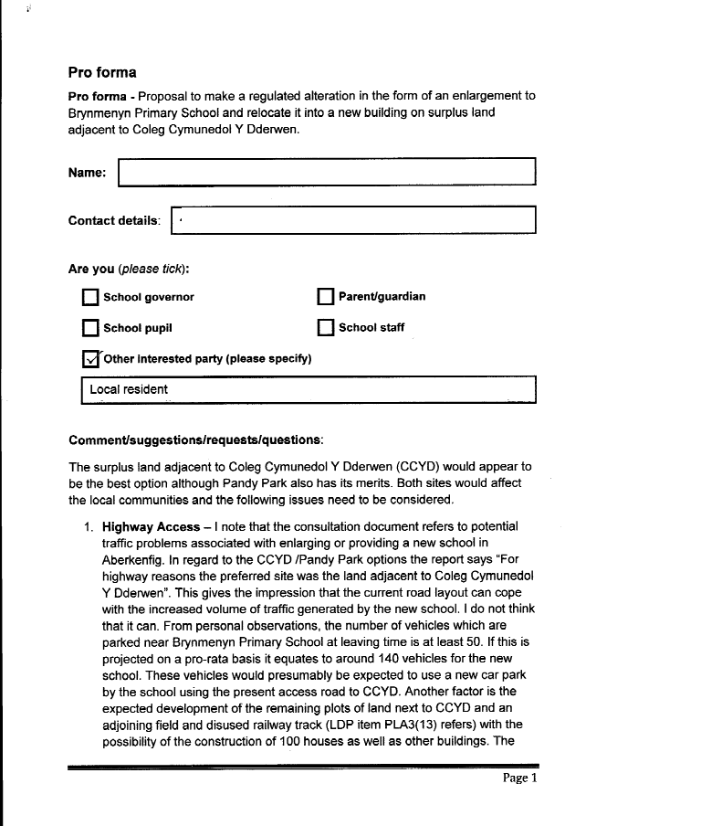

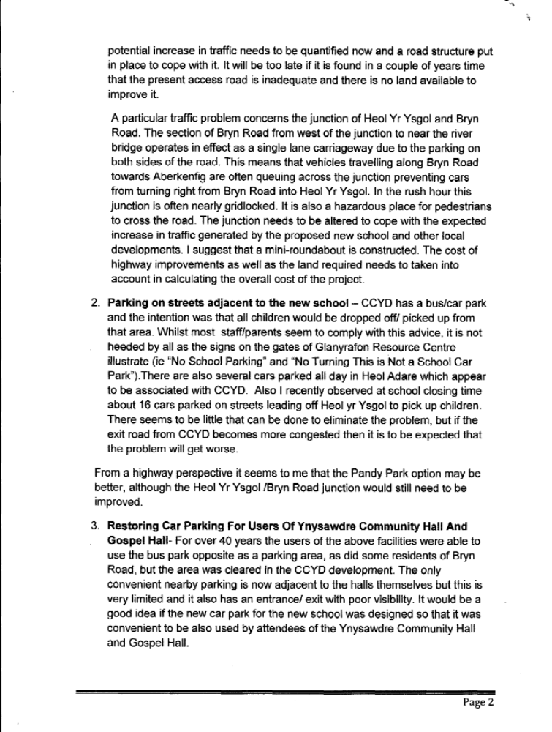

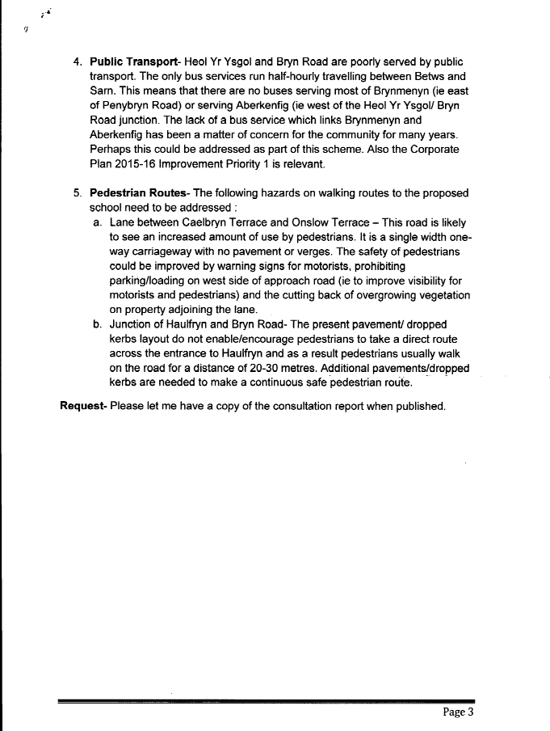

Appendix vii
Authority response
Highway Access
The report indicating that the CCYD site would be preferable to the Pandy Park site “for highway reasons” was determined as a result of the current issues that are being experienced by residents in the area of Pandy Park. The reasoning was as a result of a high level observation out of the current road layouts around CCYD and Pandy Park and it does not conclude that the roads around CCYD would be able to cope with any increase in vehicular traffic. This evidence could only be obtained from an in depth study and as such a comprehensive Traffic Assessment by an external consultant has been commissioned. The area of study will include Bryn Road/Heol Yr Ysgol as well as the wider area surrounding Brynmenyn. This will ensure that any increase in traffic as a result of relocation of Brynmenyn Primary School will be considered and suitable mitigation suggested.

Parking on streets adjacent to the new school.
Again, the Traffic Assessment currently being carried out, as detailed above, will consider the issue of on-street parking and traffic movements during the drop off and pick up times. The finding of the assessment will be considered by the Councils traffic management section and road safety officer to ensure any mitigation measures would be effective.

Car parking for Ynysawdre Community Hall.
It is intended that the new school is located at the rear of the parcel of land for development as such it is considered that any school car park will be too far away for use by users of the Community Hall. It is likely that they will park in the new and existing residential streets.

Public transport
Service No. 76 (formerly Service No. 13) and Service No. 77 (formerly Service No. 11) operates half hourly from Bridgend to Bettws (via Sarn and Ynysawdre) between 08:40 to 18:01.

Service No. 67 (formerly Service No. 4) operates from Bridgend to Bryncethin (via Pen-y-Fai, Aberkenfig and Sarn) between 07:20 to 18:30. This provides a vital link to Pen-y-Fai and Aberkenfig residents attending the Surgery in Sarn. Also provides a connection for Ynysawdre residents wishing to travel to Aberkenfig/Pen-y-Fai.

Service No. 72 (formerly Service No. 12) operates every twenty minutes from Bridgend to Blaengarw (via Brynmenyn, Llangeinor and Pontycymmer) between 06:20 to 19:36.

Service No. 73 (formerly Service No. 14) also operates via Ynysawdre early morning and late evening (Bridgend to Blaengarw).

In addition, Service No. 16 (operated by Easyway Minibus Ltd) operates from Bridgend to Blaengarw (via Sarn, Bryncethin, Brynmenyn and Bettws) approximately every hour and a half between 07:10 to 19:40.

However, there is currently no recognised bus service that operates via Bryn Road.

Pedestrian Routes.
As part of the Traffic Assessment it will include a section in the report which details walking routes that will potentially be used by users of the proposed school and the catchment areas that have been included. These routes will be assessed for the safety of pedestrians and mitigating measures suggested to overcome the identified hazards. This section of the report will then be considered by the Road Safety Officer.

Appendix viii

Estyn response to the proposal to make regulated alterations to Brynmenyn Primary School, Bridgend County Borough Council

Her Majesty’s Inspectors of Education and Training in Wales have prepared this report.
Under the terms of the School Standards and Organisation (Wales) Act 2013 and its associated Code, proposers are required to send consultation documents to Estyn. However, Estyn is not a body that is required to act in accordance with the Code and the Act places no statutory requirements on Estyn in respect of school organisation matters. Therefore as a body being consulted, Estyn will provide their opinion only on the overall merits of school organisation proposals.

Estyn has considered the educational aspects of the proposal and has produced the following response to the information provided by the proposer and other additional information such as data from Welsh Government and the views of the Regional Consortium, which deliver school improvement services to the schools within the proposal.

Introduction
The proposal is that Bridgend County Borough Council make regulated alterations to Brynmenyn Primary School by enlarging the school to two form entry and relocating the school to a new build on land adjacent to Coleg Cymunedol Y Dderwen.

Summary
The local authority’s proposal arises from the pressing need to provide more school places within the Valleys Gateway Area, and to reduce pressure for places upon two other ‘gateway’ schools. This proposal is consistent with the local authority’s strategy for school re-organisation.

It is Estyn’s opinion that this proposal will help increase the number of school places available, and benefit pupils at Brynmenin through the provision of a modern, and less crowded teaching and learning environment.

The proposal generally sets out well the rationale for the proposed action and the advantages and disadvantages arising. However, these are not laid out clearly enough to easily assess them or identify the overall weighting of the proposal.

The overall impact of the proposal on pupil performance data is difficult to assess. The proposal clearly states that there is currently an adverse impact on pupils and staff arising from the overcrowding at the school. However, it only outlines the advantages that would arise from a larger school building. The proposal does not explain clearly the expected improvements that better teaching and learning space

may have on the curriculum, on pupil performance, or on provision for more vulnerable pupils including children with Special Educational Needs.
However, the most recent Estyn inspection report and monitoring report both indicate that standards at the school, along with leadership and management are improving, and therefore a change to a new and larger school should at least maintain standards should the proposal go ahead.

Description and benefits

The proposer has given a clear rationale for the proposal, which includes addressing the issues of increasing demand for school places in the Valleys Gateway Area, as well as of the declining standard of school buildings, no disability access at the school, and large class sizes in this and other local primary schools.

The proposer clearly defines the expected benefits of the proposal. These appear to be reasonable and include the provision of modern learning facilities, better access to outdoor provision, and DDA compliant access for pupils with disabilities. The proposal also asserts reasonably that the establishment of a new school with a larger pupil population will reduce the overcrowding in the neighbouring school.

The proposer has appropriately identified advantages and disadvantages of the proposal. However, these are generally distributed across the proposal, without a summary to bring together all of those aspects considered important. This means it is difficult to assess whether all the important aspects both positive and negative have been properly considered.

The proposer has provided clear evidence to show that it has considered other alternatives to this proposal. These include maintaining the status quo, expansion of the current buildings, and alternative sites for the proposed new school. It has provided good reasons as to why these have been discounted and why the preferred option is chosen.

The proposer has suitably considered the impact of the proposal on learner travel arrangements. The new school will be sited within approximately 0.53 miles (850 metres) from the existing school site and still within its existing catchment area. If the proposal is implemented, the additional travel distance on average would be less than half a mile. The proposer therefore assumes that there will be no significant impact upon school transport requirements for this school. However, the proposal does not refer to any risk assessment of safe walking routes to school, which may arise for some pupils. The proposal could usefully set these out, or state there are none if that is the case. There may also be an adverse impact on school transport to other local primary schools, if their rolls are reduced as a result of the new and larger school. This may result in fewer pupils needing transport to these schools.

The proposer has identified that a change to the bus service may affect St Roberts RC Primary School.

The proposal also identifies the need for changes to the catchment for this school and two others (Bryncethin and Tondu). The proposal for these changes, have not yet been issued.

The proposer has provided tables showing the most recent 5-year projection of pupil population for each of the schools listed as either directly or likely to be affected by the proposal. These suggest a growing school population for each of four out of the five primary school affected.

The proposer states that there would be no impact on the Welsh language provision currently experienced by pupils at the school.

The proposal identifies three potential risks, which appear speculative, rather than based on an analysis of actual risks. The proposal does not explore any of the risks arising from delays in the development of the site or slippage in the ‘handover’ date for school pupils.

The proposer has undertaken an equality impact assessment, and a community impact assessment, which appear to address the main issues.

Educational aspects of the proposal

The proposer has clearly set out the current performance of the school, and has drawn an appropriate distinction between the relatively poorer performance of Foundation Phase pupils, with that of the key stage 2 pupils where progress is good.

The proposal appropriately states the support category for the school based on the national school categorisation system, which takes into account the view of the local authority. It also refers to the most recent Estyn inspection report and the outcome of the follow up monitoring report for the school.

The proposer clearly states the impact on the pupil population and staff of the overcrowding at the current school, and outlines the advantages that would arise from a larger school building. However, these ‘advantages’ are only identified in passing, with little or no explanation of the impact better teaching and learning space may have on the curriculum, on pupil performance, or on provision for more vulnerable pupils including children with Special Educational Needs.

Appendix ix
Equality Impact Assessment
Full Equality Impact Assessment
Name of project, policy, function, service or proposal being assessed | Proposal to make a regulated alteration in the form of an enlargement to Brynmenyn Primary School and relocate it into a new building on surplus land adjacent to Coleg Cymunedol Y Dderwen.
Date assessment completed | 02/06/15

An initial EIA screening was completed in March 2015
At this stage you will need to re-visit your initial screening template to inform your discussions on consultation and refer to guidance notes on completing a full EIA
1. Consultation
 |  | Action Points
Who do you need to consult with (which equality groups)? | Within each of the protected characteristic groups the council will need to consult with those parties identified within section 3.2 of the School Organisation Code 2013 | The consultation tools and mechanisms to be used should include: Focussed Meetings, Public Meetings, a consultation document and associated questionnaire, publication of all information on the council’s website.
How will you ensure your consultation is inclusive? | The Local Authority is mindful that as wide a range of consultation and engagement activities and tools need to be deployed in order to reach as wide an audience of consultees as possible. Consultation and engagement must be maximised in order that public views and concerns are “heard and considered” by the council.  Methods of consultation will include (where appropriate) bilingual (Welsh / English) materials, information produced in languages other than English and Welsh, and by request large print documents, easy read versions of information, provision of audio information and will include a mix of hard copy documents and provision of online forms and information. The council recognises that, key to the council’s consultation and engagement strategy is the commitment to visiting the public and other consultees in their own locations / communities at times that are convenient to them.
What consultation was carried out?  Consider any consultation activity already carried out, which may not have been specifically about equality but may have information you can use | A full public consultation took place from the 23 March 2015 to the 5 May 2015.  Those consulted included staff, governors, pupils and parents of the school, members of the local community and other interested parties.  Consultation meetings took place and are detailed in the following section.

Record of consultation with people from equality groups
Group or persons consulted | Date, venue and number of people | Feedback, areas of concern raised | Action Points
General meeting with the staff and governing body of Mynydd Cynffig Infants School | 27 April 2015  Brynmenyn Primary School  5 members of staff and governing body attended | General comments raised nothing specifically referenced in respect of protected/equality groups | n/a
General meeting with the school council of Brynmenyn primary school. | 30 April 2015  Brynmenyn Primary School  Representatives of the school council attended. | General comments raised but specifically the following question:-  Will there be disabled provision if the building is 2 storeys? | Yes there will be 1 or 2 lifts to the upper floor. There will also be disabled parking spaces in the carpark and the site is flat. We will need to segregate pedestrians from traffic.  Full DDA compliance will be provided as part of the design of the school building
General meeting with the staff and governing body of Bryncethin primary school. | 29 April 2015  Bryncethin Primary School  19 members of staff and governing body | General comments raised nothing specifically referenced in respect of equality groups | n/a
General meeting with the school council of Bryncethin primary school. | 30 April 2015  Bryncethin Primary School  Representatives of the school council attended. | General comments raised nothing specifically referenced in respect of equality groups | n/a
General meeting with the staff and governing body of Tondu primary school. | 22 April 2015  Tondu Primary school  12 members of staff and governing body | General comments raised nothing specifically referenced in respect of equality groups | n/a
Meeting with the school council of Tondu primary school. | 30 April 2015  Tondu Primary school  Representatives of the school council attended. | General comments raised nothing specifically referenced in respect of equality groups | n/a
Drop in sessions for parents, carers, members of the local community and all other interested parties. | 30 April 2015  Tondu Primary school  No attendees | n/a | n/a

2. Assessment of Impact
Based on the data you have analysed, and the results of consultation or research, consider what the potential impact will be upon people with protected characteristics (negative or positive). If you do identify any adverse impact you must:
a) Liaise with the Equalities Team who may seek legal advice as to whether, based on the evidence provided, an adverse impact is or is potentially discriminatory, and
b) Identify steps to mitigate any adverse impact – these actions will need to be included in your action plan.
There is unlikely to be any direct negative impact on any protected group other than a physical move of the school to a new location. The new school will be fully DDA compliant and will therefore have disabled facilities to support all disabled learners, staff and visitors. This is therefore considered to be a positive impact which will ensure that all learners, including those with disabilities have access to a learning environment to support their needs.

More pupils from the local communities identified by the proposal will share the same/larger school and the development would therefore support greater community cohesion. Therefore, there is likely to be a positive impact as currently some learners are admitted to more than one school as school places are limited in the area. The larger proposed school together with proposed catchment boundary changes will help ensure that pupils from the same communities are being educated in the same schools. However, there is always the potential for schools, when they have been integral to their local communities for many decades and then moved, to cause some initial anxiety within the local community and for community cohesion to be impacted. Therefore, we would seek to ensure that the benefits of the development are effectively communicated to all stakeholders and they are also able to play their role in the development and rebranding of the new school. The LA would seek to support the school in building positive relationships to mitigate any anxiety if forthcoming.

As the location of the new school in Ynysawdre will be further away by approximately 0.6km there is a potential for there to be an impact on families in particular in transporting their children to school. There may therefore be some additional traffic displaced from Brynmenyn to Ynysawdre given the school would move to its new site and as a result of a likely catchment boundary change (although this will be managed via a separate process).

Gender | Impact or potential impact | Actions to mitigate
Identify the impact/potential impact on women and men. | None envisaged as this will be an enlargement and relocation of the current school to a new site. | None envisaged
Disability | Impact or potential impact | Actions to mitigate
Identify the impact/potential impact on disabled people (ensure consideration of a range of impairments, e.g. physical, sensory impairments, learning disabilities, long-term illness). | The school would be fully DDA compliant and will therefore have disabled facilities to support all disabled learners, staff and visitors. This is therefore seen as a positive impact. | None envisaged
Race | Impact or potential impact | Actions to mitigate
Identify the impact/potential impact of the service on Black and minority ethnic (BME) people. | None envisaged as this will be an enlargement and relocation of the current school to a new site. | None envisaged
Religion and belief | Impact or potential impact | Actions to mitigate
Identify the impact/potential impact of the service on people of different religious and faith groups. | None envisaged as this will be an enlargement and relocation of the current school to a new site. | None envisaged
Sexual Orientation | Impact or potential impact | Actions to mitigate
Identify the impact/potential impact of the service on gay, lesbian and bisexual people. | None envisaged as this will be an enlargement and relocation of the current school to a new site. | None envisaged
Age | Impact or potential impact | Actions to mitigate
Identify the impact/potential impact of the service on older people and younger people. | By the very nature of this proposal, children in the current Brynmenyn Primary School in particular will be impacted more given this relates to the relocation of the school to a different location. Additionally, pupils, parents, carers and guardians may feel affected by the loss of the identity of the current school once it is disposed of with concern that this might affect community cohesion. Nevertheless, the proposal will ensure that all learners, including those with disabilities have access to a learning environment fit for the 21st century to support their needs. More pupils from the local communities identified by the proposal will share the same school and this may therefore support greater community cohesion in the long term. | Reassurance of the positive benefits of the development have already taken place. Rebranding of the school will also take place with full pupil and community involvement.
Pregnancy & Maternity | Impact or potential impact | Actions to mitigate
 | None envisaged | None envisaged
Transgender | Impact or potential impact  None envisaged | Actions to mitigate
Marriage and Civil Partnership | Impact or potential impact  None envisaged | Actions to mitigate

It is essential that you now complete the action plan. Once your action plan is complete, please ensure that the actions are mainstreamed into the relevant Thematic Service Development Plan.
3. Action Plan
Action | Lead Person | Target for completion | Resources needed | Service Development plan for this action
Reassurance of the positive benefits that the development will have on pupils/parents.  Rebranding of the school will also take place with full involvement of pupils. | Head teacher | Ongoing until school is proposed to open in January 2018 | Pupil and community participation | Communication with school.

Please outline the name of the independent person (someone other the person undertaking the EIA) countersigning this EIA below:
Nicola Echanis (Head of Strategy Partnerships and Commissioning)
Please outline how and when this EIA will be monitored in future and when a review will take place:
The EIA will be monitored via the 21st Century school programme and specifically via the project to develop the school i.e., via the Brynmenyn Primary School Project Board who will review the EIA and ensure adequate monitoring and controls are in place.
Signed: 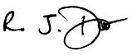 Date: 02/06/2015

4. Publication of your results and feedback to consultation groups
It is important that the results of this impact assessment are published in a user friendly accessible format.
It is also important that you feedback to your consultation groups with the actions that you are taking to address their concerns and to mitigate against any potential adverse impact.
Please send completed EIA form to the Equalities Team

Appendix x

Welsh Language Impact Assessment

Brynmenyn Primary School

Proposal to make a regulated alteration in the form of an enlargement to Brynmenyn Primary School and relocate it into a new building on surplus land adjacent to Coleg Cymunedol Y Dderwen.
It is proposed to make a regulated alteration to Brynmenyn Primary School in the form of an enlargement from the existing school size (capacity of 136 pupils plus a 26 place nursery) to a 2 form entry school (capacity of 420 pupils plus a 60 place nursery), effective from 1st September 2017. The Published Admissions Number for the new school would be 60. It is also proposed that the school relocates from its present premises to a new build school on land adjacent to Coleg Cymunedol Y Dderwen.
As the proposed enlarged and relocated English medium school would continue as is but in a larger building it is considered that there would be no impact on the Welsh language provision currently experienced by pupils at the school. Welsh would continue to be taught through the curriculum.

The authority will comply with its Welsh language policy by making sure that all signage used within the school sites are bilingual.

GT
28th May 2015

Appendix xi

Community Impact Assessment

Name of proposal:
Proposal to make a regulated alteration in the form of an enlargement to Brynmenyn Primary School, creating a 2FE school plus 60 place nursery with effect from September 2017 and to relocate the school to surplus land adjacent to Coleg Cymunedol Y Dderwen, Heol yr Ysgol, Tondu CF32 9EL.

Who will make the decision? :
Cabinet

Who has been involved in developing the proposal? :
Corporate Director – Education and Transformation
Head of Strategy Partnerships and Commissioning – Children’s
Project Manager - Property Services

Aims and objectives: Proposal to make a regulated alteration in the form of an enlargement to Brynmenyn Primary School, creating a 2FE school plus 60 place nursery with effect from September 2017 and to relocate the school on surplus land adjacent to Coleg Cymunedol Y Dderwen, Heol yr Ysgol, Tondu CF32 9EL There will be a subsequent separate exercise regarding a proposed catchment area change in respect of Brynmenyn, Tondu and Bryncethin Primary Schools in order to ensure the there is a sufficient supply of places which are located correctly for the area.

Key actions:
- Statutory procedure to enlarge Brynmenyn Primary School
- A separate exercise to consult on proposed catchment area changes - this will be undertaken at a later date.

Expected outcomes: Brynmenyn Primary School relocates to the site adjacent to Coleg Cymunedol Y Dderwen and opens as a 2FE school plus 60 place nursery in January 2018.

Who will be affected: Staff, governors, pupils, parents and the community

Approximately how many people will be affected: potentially in excess of 3000 people

Expected date of decision: September 2015

Scope/focus of the assessment: Consideration given to
- the existing use of the schools by the community;
- accessibility to pupils, staff, parents and the community;
- impact of creating a primary school
- impact on the school building
- impact on the extended community

Relevant data and/or research:
- information provided by Brynmenyn Primary School, Bryncethin Primary School and Tondu Primary School in terms of community use of the existing school premises
- information provided by Brynmenyn Primary School, Bryncethin Primary School and Tondu Primary School in terms of after school clubs offered at each school
- 2006 BCBC report entitled ‘Strategy, Principles, Policy and Planning Framework’ which informs the approach for addressing strategic priorities within the County Borough
- pupil projections, capacity, building conditions

Findings:

Community Use:
- Brynmenyn Primary School
Language and Play;
Numeracy and Play
OLAP sessions
Reading café’s
Challenge Afternoons

- Tondu Primary Scool
Nursery - Link up, Language and Play
Reception, Year 1 – Reading café, Welsh and Play, Number and Play, Family Activity Zone, Linger and Learn
Year 2 Family Activity Zone, Linger and Learn
Year 3, Year 4 Linger and Learn, drop in sessions for aspects of learning, Computer coding
Year 5, Year 6 Linger and Learn, drop in sessions for aspects of learning
- Bryncethin Primary School

School Clubs:
- Brynmenyn Primary School
A range of clubs are offered: rugby, football, netball, basketball, Eco club, choir and art
The school operates a breakfast club
- Tondu Primary School
A range of clubs weekly; mixed activities, sports club such as football, fencing, cookery, Eco club.
Simply After School provide paid sessional activities for parents from 3.00-6.00pm
The school has two breakfast clubs, one on Heol Persondy and one on Meadow Street.

- Bryncethin Primary School
A range of clubs are offered: netball, rugby, craft, science, Welsh/story café, French, ICT and orchestra

Primary Policy:
- This proposal aligns with the Council’s 2006 education principles and policy regarding provision – ‘Learning Communities – Schools of the Future’

Pupil projections, capacity, building condition:
- The pupil projections affecting primary schools in the Valley’s Gateway area are increasing – set to rise from 644 (Jan 15) to 896 (Jan 22). In the future, additional pupil places will be required to serve the Valleys Gateway area and to meet the demand for pupil places from housing development
- Building conditions in respect of the three schools serving the area i.e. Brynmenyn, Tondu and Bryncethin Primary Schools are category B (satisfactory - performing as intended but exhibiting minor deterioration).
- Accessibility of Brynmenyn Primary School is categorised as D -inaccessible, non-compliant with DDA and cannot be made so without major expense if at all. Tondu and Bryncethin Primary Schools are categorised as B – largely accessible - largely compliant with DDA but some works still required.

Impact on extended community
- Changes to the catchment will impact on the service bus provided to Sarn. Although Sarn is within the criteria for local schools, Pandy Park is not seen as a safe route to school. The LA subsidises an escort on this service. However pupils have to be escorted to the bus by staff to ensure their safety whilst waiting for it. Tondu Primary School puts a lot of time into ensuring this, using bus cards and telephone calls to register pupils on the bus, and ensuring they wait in school at the end of the day before being taken to the bus. This reduction in use will impact on St Roberts. Whilst the reduction in numbers using the bus will be welcomed by some, it may impact on viability.
- Areas within the Valleys Gateway have very different communities in terms of character. All have strengths and offer positive support. However they are geographically spread out it would be of benefit for the catchment to be redrawn to allow the children and their families to access their school more easily.
- Highway, parking and pedestrian routes were raised as an issue during the consultation process. A Transport Impact Assessment has been commissioned which will determine suitable mitigation measures, if required.

Impact on other schools
- It may well be that parents would prefer a smaller school or not welcome the proposed change in catchment, choosing for their children to be taught in an alternative school, should the proposal go ahead.
- A change to the bus service may impact on St Roberts RC Primary School

How will the decision affect people with different protected characteristics? :
There is likely to be a positive impact for disabled groups as the proposed Brynmenyn Primary School, being a new build provision, would be DDA compliant.

For Tondu Primary School, all pupils being located on Meadow Street will improve accessibility.

Consultation

Has there been specific consultation on this decision (if not, state why not and/or when this may happen):
Yes – consultation exercise undertaken from 23rd March – 5th May 2015

What were the results of the consultation? :
The impact of this proposal was considered and further responses were requested as part of the consultation, outcome of which have been recorded and reported to Cabinet in the Consultation Report

Across the protected characteristics, what difference in views did analysis of the consultation reveal?
None

What conclusions have been drawn from the analysis on how the decision will affect people with different protected characteristics?
No differential impacts likely

Assessment of impact on staff

Please give details of impact on staff, including staffing profile if/as appropriate:
The proposal may have an impact on teaching and non-teaching staff. Determination of this is a matter for the governing body once they understand the needs of the individual schools and the budget available to them in order to determine the staffing structures required.

Assessment of impact on wider community

Please give details of any impacts to the community as a whole:
The community may not wish for the existing buildings at Brynmenyn Primary School and the building located at Heol Persondy, which is part of Tondu Primary School, to close.

Analysis of impact by protected characteristics

Please summarise the results of the analysis:
It is considered that the characteristics affected could be that of age and disability

Assess the relevance and impact of the decision to people with different characteristics Relevance = High/Low/None Impact = High/Low/Neutral

Characteristic | Relevance | Impact
Age | High | Low
Disability | High | Low
Gender reassignment | None | Neutral
Marriage and civil partnership | None | Neutral
Pregnancy and maternity | None | Neutral
Race | None | Neutral
Religion or belief | None | Neutral
Sex | None | Neutral
Sexual orientation | None | Neutral
Other socially excluded groups (include health inequalities) | None | Neutral

Where any negative impact has been identified, please outline the measures taken to mitigate against it:
Subject to the statutory procedure and the subsequent outcome of consultation on proposed catchment changes, the Authority will:
- Work with the governing bodies and schools to support them in determining staffing structures.
- Encourage and support the schools in the continued provision of community use of the school buildings.
- Ensure a smooth transition by working closely with the schools.

Please advise on the overall equality implications that should be taken into account in the final decision, considering relevance and impact:
No differential impacts likely

Signed:
G Thomas

Date:
28/05/15

