Bridgend County Borough Council

Proposal to make a regulated alteration to Coychurch Primary in the form of an enlargement
Consultation document

Date of issue: 06.09.2017
Action required: 17.10.2017

Tel: (01656) 642 617
Email: Ellen.Franks@bridgend.gov.uk
Web: www.bridgend.gov.uk/consultation

www.bridgend.gov.uk

Contents

Overview 3
How to respond 3
Data protection 3
The proposal 4
What the proposal means in practice 4
Why has this proposal been brought forward? 4
Governing Body 6
Staffing Issues 6
What are the advantages if the proposal goes ahead? 6
Finance 7
What are the potential disadvantages if the proposal goes ahead? 8
Details of the affected school(s) 8
Land and buildings 10
Other considerations 10
Impact Assessments 11
The consultation and statutory process 11
Pro forma 14
Appendix A 15
Appendix B 17
Appendix C 18
Appendix D 19

Overview
This consultation is to invite your views on the proposal to make a regulated alteration to Coychurch Primary in the form of an enlargement.
Those consulted will include staff, governors, pupils and parents of the school, members of the local community and any other interested parties.

How to respond
This consultation period will begin on the 6 September 2017 and close the 17 October 2017.
You can respond or ask further questions in the following ways;
Tel: (01656) 642 617
Email: Ellen.Franks@bridgend.gov.uk
Online: www.bridgend.gov.uk/consultation
Post: Education and Family Support, Bridgend County Borough Council, Civic Offices, Angel Street, Bridgend, CF31 4WB.
This document is available in Welsh.
Alternative formats are also available upon request.

Data protection
How we use the views and information you share with us
All responses received by Bridgend County Borough Council will be seen in full by its staff members involved in the consultation process. The information may also be seen by other departments within the council or local service board members to help improve upon the services provided.
The council may also use the information gathered to publish subsequent documents both directly and indirectly linked to this consultation, however the Council will never disclose any personal information such as names or addresses that could identify an individual.
If you do not wish for your opinions to be publicised, please state so in your response.

The proposal
It is proposed to make a regulated alteration to Coychurch Primary in the form of a permanent enlargement - from the existing school capacity of 67 pupils aged 4-11 (plus a 23 place nursery) to a school capacity of 127 pupils (plus a 23 place nursery), effective from 1st January 2018.
In order to take this forward, it is necessary to carry out a consultation exercise with staff, parents, pupils, interested parties and the governing body as the first step in the statutory process.

What the proposal means in practice
This proposal would see Coychurch Primary enlarged to a 127 pupil capacity school effective from 1 January 2018.

Why has this proposal been brought forward?
In March 2015, the Council approved 5 key principles within a policy and planning framework which would inform the organisation and modernisation of our schools:

- Commitment to high standards and excellence in provision
- Equality of opportunity, so that all pupils can access quality learning opportunities, regardless of which school they attend
- Inclusive schools, which cater for the learning needs of all their pupils
- Community focused schools, where the school actively engages with its local community
- Value for money
The policy and planning framework set out 17 areas where these principles should apply, particularly relevant in the context of this proposal is the size of primary schools (to ensure that “all Bridgend’s primary schools are large enough to make the full range of necessary provision”).

As at January 2017, Coychurch Primary School had 23 nursery pupils and 123 pupils aged 4-11 on roll. In the academic year 2016/17, the capacity of the School was calculated as 67 in respect of pupils aged 4-11. Currently the published admission number in respect of pupils admitted to reception is 19.

In 2013, Bridgend County Borough Council made a temporary capacity increase at Coychurch Primary School (the capacity temporarily increased from 81 pupil places to 134) by installing a double mobile classroom on the school site. The temporary increase was required as the Council agreed in November 2012 that the new Linc Cymru development in the north-east of Brackla would be assigned to the catchment area of Coychurch Primary School, with effect from September 2014 (it was further agreed that the situation would be in place for a period of five years and be reviewed in 2019).

Pupil numbers in the south east of the County Borough are now such that, even with the new Coety Primary school opened, the temporary Coychurch Primary School capacity increase needs to be made permanent to support the efficient admission of pupils. Prior to the temporary installation of the double mobile classroom on the school site the Published Admission Number for the school was 12

In order to continue to accommodate pupil numbers, it has become necessary for the school to utilise the double mobile classroom installed in 2013 which was originally intended to be used for teaching and storage and since 2013 has been used consistently for teaching purposes. This has resulted in an increase to the capacity of the school and this change has been implemented on a temporary basis until now.

It is considered that there is a need to formalise this temporary arrangement in order to comply with the School Organisation Code.

The capacity of the school five years prior to the date of the proposed implementation (i.e. 2012-2013) was 93. The permanent addition of mobile classroom spaces at the school will result in the capacity increasing to 127 which is greater than 25% of the current capacity. As a result, the published admission number in respect of pupils admitted into reception will increase to 19 (resulting in an 18 place nursery). In order to formalise this increase in capacity, it is necessary to undertake a regulated alteration to enlarge the school under the School Standards and Organisation (Wales) Act 2013, as set out in the School Organisation Code (the Code).

School | Jan-17 |  |  | Jan-25 Projected
 | Capacity | NOR  4-11 | +/- | Capacity | NOR  4-11 | +/-
Coychurch | 67 | 149 | -82 | 127 | 175 | -48
Coety Primary | 420 | 383 | +37 | 420 | 763 | -343
Croesty Primary | 205 | 238 | -33 | 205 | 202 | +3
Pencoed Primary | 454 | 563 | -109 | 510 | 488 | +22
*NB Pupil projections do not include for additional pupils each year from new housing developments

As an alternative to the proposal, the Council could elect to ‘do nothing’ and not pursue a permanent enlargement of Coychurch Primary. However, given that the school has already been utilising existing space for teaching purposes for some time in order to accommodate pupil numbers – the proposed formal permanent enlargement is the logical choice.
The Authority would struggle to meet demand in an efficient and cost effective manner, if the proposed permanent enlargement of Coychurch Primary is not pursued.

Governing Body
The result of the proposal, should it go ahead, would be that the Governing body arrangements would remain as at present.

Staffing Issues
The result of the proposal, should it go ahead, would mean that the staffing complement would likely remain as at present.

What are the advantages if the proposal goes ahead?

Quality and standards in education

Outcomes (standards and wellbeing);
Standards in Coychurch Primary School are good. There is an improving trend in performance at the expected and higher than expected outcomes in the foundation phase and at key stage 2. The school is in Welsh Government standards group 2 (there are 4 groups with group 1 being the highest achieving and group 4 the lowest). If the proposal goes ahead the additional capacity is likely to result in continued trends of improvement.

Provision (learning experiences, teaching, staffing, care support and guidance, and learning environment);
The quality of teaching in Coychurch Primary School is good and is unlikely to be detrimentally effected by the proposal, given that the school has already been successfully utilising existing space for teaching purposes for some time in order to accommodate increased pupil numbers.

Leadership and management (leadership, improving quality, partnership working and resource management);
The leadership of the school is good and the school has good capacity to improve. The leadership and management of the school would be unlikely to be affected in any negative way by the proposal, given that the school has already been successfully utilising existing space for teaching purposes for some time in order to accommodate increased pupil numbers.
The proposal will improve the capacity of Coyhurch to deliver the full curriculum at the foundation phase and at key stage 2.
The proposed changes are not likely to affect the quality and standards of education in any other schools in the area.

Finance
The area being utilised for teaching purposes to accommodate the pupil numbers which would be incorporated into the capacity calculation is within the school building and is already fully funded via the school’s funding formula allocation. Should additional pupils be admitted to the school additional funding for staff may be required. This will either be funded through the school funding formula or the school retrospective adjustment once the pupil numbers have been confirmed.

What are the potential disadvantages if the proposal goes ahead?
There is a risk that some parents may prefer to have their children educated at a smaller school site.

Details of the affected school(s)
The following schools have been identified as being directly affected or likely to be affected by the proposal:

Coety Primary  Ffordd Yr Hebog  Coity  CF35 6DH | Croesty Primary  73 Coychurch Road  Pencoed  Bridgend  CF35 5LY  Pencoed Primary  Penprysg Road  Pencoed  CF35 6RH
The table below provides details of the January 2017 numbers on roll at each of the schools and the figures recorded for the previous four annual censuses.
 | Jan-2013 |  | Jan-2014 |  | Jan-2015 |  | Jan-2016 |  | Jan-2017
 | F/T | P/T | F/T | P/T | F/T | P/T | F/T | P/F | F/T | P/T
Coychurch Primary | 86 | 3 | 91 | 2 | 103 | 3 | 123 | 5 | 142 | 7
Coety Primary  Croesty Primary | 168  234 | 4  14 | 184  534 | 5  4 | 226  546 | 0  6 | 313  555 | 12  1 | 370  549 | 13  14
Pencoed Primary | 524 | 14 | 534 | 4 | 546 | 6 | 555 | 1 | 549 | 14

The table below provides a 5 Year projection of pupil population for Coychurch English Medium Primary School. Capacity of Coychurch is 67 with an admission number of 19 and buildings rated Condition grade B. Latest Estyn inspection judgement – Good.

NB Pupil projections do not include for additional pupils each year from new housing developments:
Year | Nursery 1 | Nursery 2 | Reception | Year 1 | Year 2 | Year 3 | Year 4 | Year 5 | Year 6 | Total
 | 2-3 | 3-4 | 4 - 5 | 5 - 6 | 6 - 7 | 7 - 8 | 8 - 9 | 9 - 10 | 10 - 11 | 2-11
2018 | 4 | 16 | 21 | 27 | 17 | 23 | 24 | 11 | 19 | 162
2019 | 5 | 17 | 17 | 23 | 28 | 19 | 27 | 29 | 11 | 176
2020 | 5 | 17 | 17 | 18 | 24 | 32 | 23 | 32 | 30 | 198
2021 | 5 | 17 | 17 | 18 | 20 | 28 | 38 | 27 | 34 | 204
2022 | 5 | 17 | 18 | 19 | 20 | 22 | 33 | 46 | 29 | 209

The table below provides a 5 year projection of pupil population for Coety English Medium Primary School. Capacity of Coety Primary is 420 with an admission number of 60 and buildings rated Condition grade A. Latest Estyn inspection judgement – Good.

NB Pupil projections do not include for additional pupils each year from new housing developments:
Year | Nursery 1 | Nursery 2 | Reception | Year 1 | Year 2 | Year 3 | Year 4 | Year 5 | Year 6 | Total
 | 2-3 | 3-4 | 4 - 5 | 5 - 6 | 6 - 7 | 7 - 8 | 8 - 9 | 9 - 10 | 10 - 11 | 2-11
2018 | 8 | 62 | 62 | 78 | 62 | 60 | 42 | 47 | 39 | 460
2019 | 8 | 62 | 62 | 78 | 95 | 70 | 72 | 46 | 51 | 544
2020 | 8 | 62 | 62 | 78 | 95 | 107 | 84 | 79 | 50 | 625
2021 | 8 | 62 | 62 | 78 | 95 | 107 | 128 | 92 | 85 | 717
2022 | 8 | 62 | 62 | 78 | 95 | 107 | 128 | 141 | 99 | 780

The table below provides a 5 year projection of pupil population for Croesty English Medium Primary School. Capacity of Croesty Primary is 205 with an admission number of 30 and buildings rated Condition grade B. Latest Estyn inspection judgement – Adequate.
Year | Nursery 1 | Nursery 2 | Reception | Year 1 | Year 2 | Year 3 | Year 4 | Year 5 | Year 6 | Total
 | 2-3 | 3-4 | 4 - 5 | 5 - 6 | 6 - 7 | 7 - 8 | 8 - 9 | 9 - 10 | 10 - 11 | 2-11
2018 | 1 | 29 | 31 | 31 | 30 | 30 | 29 | 31 | 24 | 236
2019 | 1 | 29 | 29 | 31 | 30 | 29 | 29 | 31 | 31 | 240
2020 | 1 | 29 | 29 | 29 | 30 | 30 | 29 | 30 | 31 | 238
2021 | 1 | 29 | 29 | 28 | 28 | 30 | 29 | 30 | 30 | 234
2022 | 1 | 29 | 30 | 29 | 28 | 28 | 29 | 31 | 30 | 235

The table below provides a 5 year projection of pupil population for Pencoed English Medium Primary School. Capacity of Pencoed Primary is 454 with an admission number of 70 and buildings rated Condition grade B. Latest Estyn inspection judgement – Good.
Year | Nursery 1 | Nursery 2 | Reception | Year 1 | Year 2 | Year 3 | Year 4 | Year 5 | Year 6 | Total
 | 2-3 | 3-4 | 4 - 5 | 5 - 6 | 6 - 7 | 7 - 8 | 8 - 9 | 9 - 10 | 10 - 11 | 2-11
2018 | 6 | 66 | 70 | 65 | 76 | 77 | 64 | 72 | 70 | 566
2019 | 7 | 66 | 67 | 72 | 64 | 79 | 76 | 64 | 72 | 567
2020 | 7 | 66 | 67 | 68 | 72 | 67 | 79 | 76 | 63 | 565
2021 | 7 | 66 | 66 | 68 | 68 | 75 | 67 | 79 | 76 | 572
2022 | 7 | 66 | 67 | 68 | 68 | 71 | 75 | 67 | 79 | 568

Land and buildings
The capacities of schools are calculated based on the Welsh Government Circular No 21/2011 ‘Measuring the Capacity of Schools in Wales’. The capacity Coychurch Primary School is currently 67 (4-11 years).
The quality of accommodation at Coychurch is graded ‘B’ (performing as intended
but exhibiting minor deterioration) with an estimated £331,850 backlog of repairs and maintenance.

Other considerations
The current premises and site would continue to operate where it is as a 127 pupil place capacity school under the proposal.
The admissions authority for the proposed enlarged Coychurch Primary School would be Bridgend County Borough Council. Admission arrangements would be as detailed within the Council’s ‘Starting School booklet – A Guide to Bridgend Council’s Policy & Admission Arrangements for Schools’. Admission number for the enlarged school would be 19.

A summary of Her Majesty’s Inspectorate for Education and Training in Wales (Estyn) most recent inspection reports relating to Coychurch Primary are included at appendix A and B for your information. The full inspection reports are available from the Estyn website.

Impact Assessments

Community Impact Assessment
The school would continue to at its present location as an enlarged school under the proposal. No negative impact on the community is anticipated as a result of the proposal. The consultation will allow interested parties to state what they see as the likely effects on the respective communities.

Equality Impact Assessment
As part of the overall process, the council has a duty to consider the implications of any proposal on all members of the local community who may be affected unfairly as a result of the proposal being carried out. An initial assessment has been made of the potential for inequality of opportunity arising from these proposals and a full equalities impact assessment will be undertaken in parallel with the consultation process. The outcomes and actions identified by this assessment will be included in and form part of the report to Cabinet on the outcomes of the consultation process. If you have any views on the potential of this proposal to affect any groups or individuals either positively or adversely, then we would welcome your comments as part of this consultation.

The consultation and statutory process
The consultation process will be completed by 17 October 2017 and the outcomes (which will be incorporated into the proposal where possible) will be reported to a subsequent Cabinet meeting. If there is a decision not to proceed, that will be the end of this proposal for the foreseeable future and an alternative proposal will need to be sought.
If the decision is to go ahead, a statutory notice outlining the proposals would need to be published for a period of 28 days and any formal written objections would be invited during this time. If there are objections at this Public Notice stage, Cabinet will need to consider the proposal. Cabinet could then accept, reject or modify the proposal. If there are no objections to the proposal, then it will go ahead subject to final approval by Cabinet.

The provisional timetable and procedure are as follows:
Activity | Date
Consultation period where we welcome your views and observations on the proposal*. | 6 September 2017 to  17 October 2017
Consultation Report to Cabinet on the outcomes of the consultation. | 31 October 2017
Publish Consultation Report on BCBC website, hard copies available on request. | 3 November 2017
If agreed by the Cabinet of Bridgend County Borough Council, a Public Notice will be published and there will be a period of 28 days in which to submit any objections to the proposal in writing. | 6 November 2017
End of Public Notice period. If there are no objections Cabinet can immediately decide whether to proceed or not. If there are any objections, an Objections Report will be published and forwarded to Cabinet for their consideration and subsequent determination. | 3 December 2017
Potential implementation. | 1 January 2018
*Please note that responses to consultation will not be counted as objections to the proposal and that objections can only be registered following publication of the Public Notice.

What do you now have to consider?
You are invited to consider the proposal and submit your views as to whether or not you support the proposal to enlarge Coychurch Primary School

How to make your views known?
There will be consultation meetings held as detailed overleaf for the different interested parties. You are invited to attend the relevant meeting where you can hear an explanation of the proposal, put questions and express any views or concerns you may have.

Venue: Coychurch Primary School | Date | Time
Meeting with the staff and the governing body | 19/09/2017 | 4.00pm
Meeting with the School Council | 22/09/2017 | 10.00am
Drop in sessions for parents, carers, members of the local community and all other interested parties (*Please contact Ellen Franks on 01656 642617 to book a place for the drop in session) | 05/10/2017 | 4.00pm to 6.00pm

If you have any questions regarding this proposal, wish to put your views in writing, suggest alternative proposals or request a copy of the consultation report when published, please contact (using the attached pro forma):
Post: Education and Family Support, Bridgend County Borough Council, Civic Offices, Angel Street, Bridgend, CF31 4WB. | Please mark for the attention of Ellen Franks, or Email: ellen.franks@bridgend.gov.uk  Online: www.bridgend.gov.uk/consultation  Tel: (01656) 642 617
Alternative formats are also available upon request. All views must be received by no later than 17 October 2017.

Pro forma
Pro forma - Proposal to make a regulated alteration to Coychurch Primary in the form of an enlargement

Name:

Contact details:

Are you (please tick):
 | School governor |  | Parent/Guardian
 | School pupil |  | School staff
 | Other interested party (specify)

Comment/suggestions/requests/questions:

Do you agree with the proposals?

The reasons for your choice?

Appendix A
Summary of Estyn, Her Majesty’s Inspectorate for Education and Training in Wales inspection of Coychurch (Date of inspection: 2014)
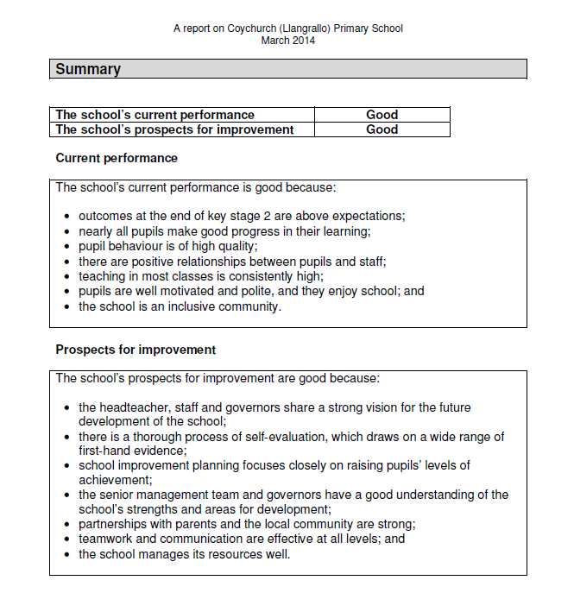

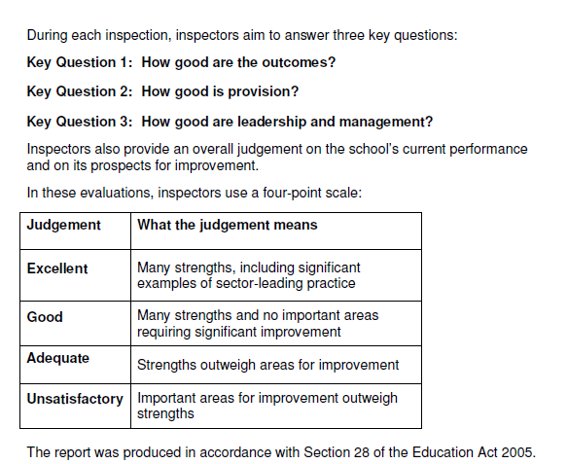
This and other Estyn publications are available on the ESTYN website: www.estyn.gov.uk

Appendix B
Summary of Estyn, Her Majesty’s Inspectorate for Education and Training in Wales inspection of Coety Primary (Date of inspection: 2011)
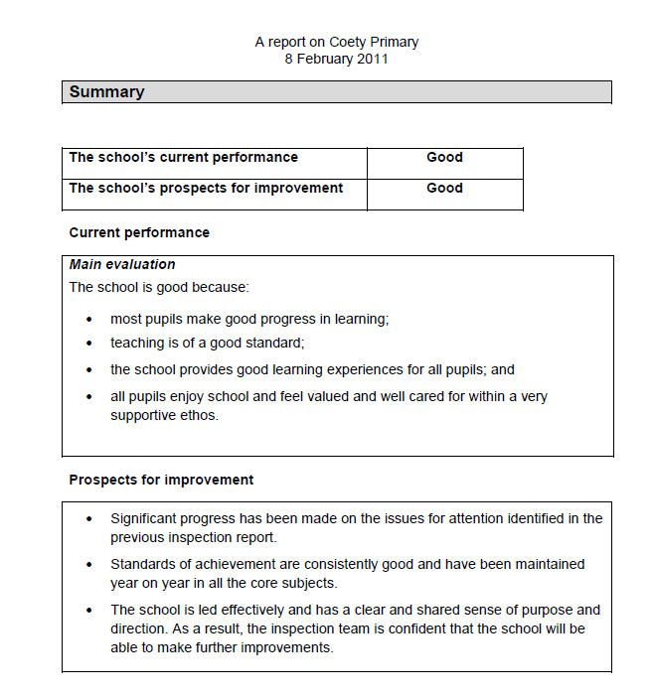

Appendix C

Summary of Estyn, Her Majesty’s Inspectorate for Education and Training in Wales inspection of Croesty Primary (Date of inspection: 2013)

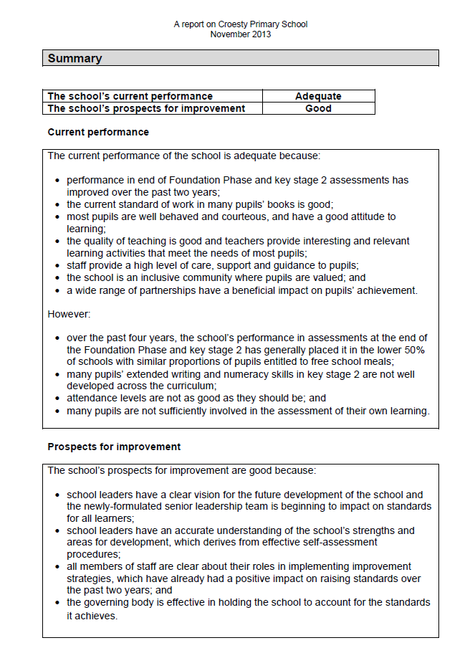

Appendix D
Her Majesty’s Inspectorate for Education and Training in Wales Report Following Monitoring Croesty Primary School (Date of visit: 2015)

Croesty Primary School
Outcome of the monitoring visit
Croesty Primary School is judged to have made good progress in respect of the key issues for action following the Estyn visit in January 2015. The school has been removed from the list of schools requiring Estyn monitoring. There will be no further Estyn monitoring visits in relation to this inspection.

Appendix E
Summary of Estyn, Her Majesty’s Inspectorate for Education and Training in Wales inspection of Pencoed Primary (Date of inspection: 2011)
