BRIDGEND COUNTY BOROUGH COUNCIL

CONSULTATION REPORT

REPORT OF THE CORPORATE DIRECTOR – EDUCATION AND FAMILY SUPPORT

SCHOOL MODERNISATION PROGRAMME: Outcome of Consultations on proposal to make a regulated alteration in the form of permanent enlargement to Coychurch Primary School

- Purpose of report

  - This report is to inform of the outcome of the consultation on the proposal to make a regulated alteration to Coychurch Primary School in the form of an enlargement with effect from 1 January 2018.

- Connection to Corporate Improvement Objectives/ Other Corporate Priorities

  - The school modernisation programme supports many of the corporate priorities, in particular:

- Smarter use of resources
- Supporting a successful economy

- Background

3.1 On 3 March 2015, Cabinet approval was received for the Council to adopt revised principles as a framework for school organisation in Bridgend; five key principles were set out to inform the organisation and modernisation of our schools:

- Commitment to high standards and excellence in provision;
- Equality of opportunity, so that all pupils can access quality learning opportunities, regardless of which school they attend;
- Inclusive schools, which cater for the learning needs of all their pupils;
- Community focussed schools, where the school actively engages with its local community; and
- Value for money.

3.2 The Policy and Planning Framework sets out 17 areas where these principles should be applied in practice.

3.3 The principles which are particularly relevant in the context of this proposal concern the size of primary schools (to ensure that “all Bridgend’s primary schools are large enough to make the full range of necessary provision”) and value for money, efficiency and effectiveness and the provision of local schools, planning new provision to reflect changes in the distribution of the population.

3.4 In 2013, Bridgend County Borough Council made a temporary capacity increase at Coychurch Primary School (the capacity temporarily increased from 81 pupil places to 134) by installing a double mobile classroom on the school site. The temporary increase was required as the Council agreed in November 2012 that the new Linc Cymru development in the north-east of Brackla would be assigned to the catchment area of Coychurch Primary School, with effect from September 2014 (it was further agreed that the situation would be in place for a period of five years and be reviewed in 2019).

3.5 Pupil numbers in the south east of the County Borough are now such that, even with the new Coety Primary school opened, the temporary Coychurch Primary School capacity increase needs to be made permanent to support the efficient admission of pupils.

3.6 Prior to the temporary installation of the double mobile classroom on the school site the Published Admission Number for the school was 12.
As a result, the published admission number in respect of pupils admitted into reception will increase to 19 (resulting in an 18 place nursery).

- Current situation

4.1 Consultation was carried out between 6 September 2017 and 17 October 2017 in accordance with the statutory School Organisation Code. A copy of the consultation document was also made available during this time on the Council’s website:

http://www1.bridgend.gov.uk/services/consultation.aspx

4.2 The consultation document invited views and opinions to be submitted in respect of the proposal.

4.3 This consultation report sets out in detail a summary of the issues raised by consultees and the authority’s responses to these.

- Summary responses to consultation

  - Key points from the consultation exercises were as follows, with full details appended at the end of this report.

  - Pupil Consultation

BCBC representatives met with the School Council of Coychurch Primary School on 22 September 2017 to discuss the proposal. A Council representative explained that the proposal is not seeking to make the school building physically bigger – the school already has the double mobile classroom that has been in use for many years on a temporary basis. There are no physical changes to the buildings. The School Council were asked if they had any questions or concerns regarding the proposal – none were raised and the School Council indicated that they were unanimously in favour of the proposal.

Details of the meeting, including the Authority’s responses to issues raised are included in this report at Appendix 1.

  - Parents and Interested Parties Consultation
BCBC representatives attended a ‘drop-in’ session that had been arranged for parents and interested parties on 5 October 2017 (4pm - 6pm) in order to discuss the proposal. No parents or interested parties turned up to the session.

  - Staff and Governors Consultation
BCBC representatives held a joint meeting with the Staff and Governing Body of Coychurch Primary on 19 September 2017 in order to discuss the proposal. Comments received in relation to the proposal were positive (details of the meeting, including the Authority’s responses to issues raised are included in this report at Appendix 2).

11 proformas were received at the close of the meeting from staff/governors and all were in support of the proposal (see Appendix 7).

5.5 Summary of on-line survey

No respondents accessed the online survey.

5.6 Direct correspondence

2 items of direct correspondence were received during the consultation period regarding the proposal (see Appendix 8). The Authority’s response to these items of correspondence are appended (see Appendix 9).

- The view of Estyn, her Majesty’s Inspectors of Education and Training in Wales

Summary / Conclusion
The proposer has outlined purposefully the advantages of the proposal in addressing the increasing demand for English-medium primary school places in the area.
Estyn is of the opinion that the proposal is likely to at least maintain the current standards in terms of education, provision, and leadership and management (see Appendix 6).

7. Equality Impact Assessment

  - An Equality Impact Assessment has been carried out as part of the consultation stage and has been further informed by responses to the consultation papers. The assessment has concluded that there is no negative impact anticipated (see Appendix 3).

7.2 A Welsh Impact Assessment has been carried out as part of the consultation. The assessment has concluded that there is no negative impact anticipated (Appendix 4).

7.3 A Community Impact Assessment has been carried out as part of the consultation. The assessment has concluded that there is no negative impact anticipated (Appendix 5).

- Financial implications

8.1 The proposal merely formalises the existing temporary arrangement in order to meet demand. The area which would be permanently incorporated into the capacity calculation (i.e. the double mobile classroom) is already within the school site and is already fully funded via the funding formula allocation.

Hard Copies of this report are available on request from:

Ellen Franks
c/o Corporate Director – Education and Family Support
Education and Family Support,
Civic Offices
Angel Street
Bridgend
CF31 4WB

Telephone number: (01656) 642617

Or by e-mail from: ellen.franks@bridgend.gov.uk

Appendix 1

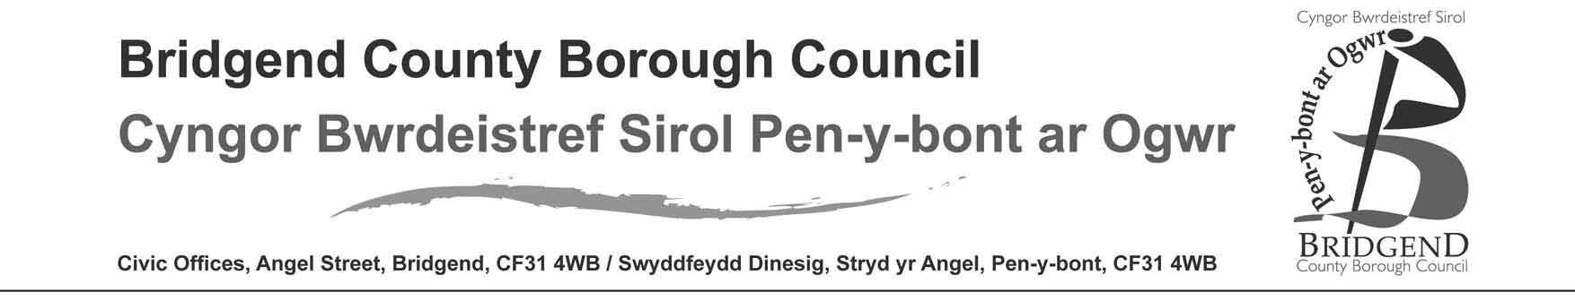

Consultation Meeting
Venue Coychurch Primary School
School Council
Date: 22/09/2017
Time: 10:00

Present: Sam. Connell, Chris Lewis, C Jones (Senior Teacher)

Members of the Council: Year 6-JH, HL, EC, IT, CW. Year 5-GA. Year 4- RT. Year 3- RJ. Year 2-SP. Year 1- AT.

Chris Lewis (CL) communicated an overview of the consultation document and the background information in regards to the mobile classroom. CL provided an introduction to the consultation proposal document of making the current temporary mobile permanent and set out the purpose of the meeting, nature and process of the consultation.

Questions/Issues | Answer/Comments
Does anyone have any questions  Do you think it’s a good idea to make the mobile classroom permanent?  Does anyone think it’s a bad idea to keep the mobile classroom?  Shall we have a vote of hands on how many of you think it’s a good idea and want to go ahead with making the mobile classroom permanent? Put your hands up if you think it’s a good idea and want to go ahead with the proposal.  Does anyone have and further questions? | No  Yes  No  Everyone’s hands went up. Unanimous vote to, it’s a good idea and want to go ahead with making the mobile permanent.  No

Appendix 2

Consultation Meeting
Venue Coychurch Primary School
School Staff and Governors
Date: 19/09/2017
Time: 16:00

Present: Sam. Connell, Chris Lewis, Paul Smith, Julie Jones, Huw Lewis, Sue Hurry, Elaine, Ken Smith, John Bowman

Members of the Staff:

Chris Lewis (CL) communicated an overview of the consultation document and the background information in regards to the original installation of the mobile classroom and a summary review of the Welsh Government (WG) school organisation code. CL provided an introduction to the consultation proposal document for making the current temporary mobile permanent and set out the purpose of the meeting, nature and process of the consultation.

Questions/Issues | Answer/Comments
I understand that this process is to just ‘rubber stamp’ and make official the temporary mobile, which we currently already have on site. However I am concerned on the current pupil growth at the school and the projected numbers. We started with 80 children at this school, which then grew to 100 after the mobile arrived; now we have 145 pupils. What are the future plans for the school? Will the catchment be looked at? What is BCBC going to do with the capacity of the schools Vs what is the projected pupil numbers for the school?  I have no issue with the mobile, it provides security for the schools future and it is fantastic that it has grown. My concerns are what are BCBC future plans with this school, with regards to this school having too many pupils for the capacity of the building as per the projection figures in the consultation document.146-180 pupils. Can you tell us the plans from the authority as a forward plan e.g. another classroom supplied. The school has limited space to house more pupils and the playground (hard surface) is too small now with the current pupil numbers, net alone an increase in them. We feel we need the opportunity to raise our concerns on pupil numbers at this school.  Maintenance on the school and its classrooms needs looking at, as well as; the parking space is too small and tight; the playground is too small in regards to hard surface. There are going to be 600+ houses being built in the surrounding area, also an additional 40+ houses in Waterton, where are those kids going to go? As this school is not big enough to take them or pick up the overflow of out of catchment children. The strategic planners need to put something in place now, on dealing with these issues. I have also spoken to Paul in the highways department and I have designed some footbridges to enable school children to walk to school and give them a safe walking route, for the children not living in Coychurch. This is instead of BCBC busing kids here, which would save the authority some money in the long term.  This is a ‘rubber stamp’ exercise to make this temporary mobile permanent, which I fully understand and you are just going through the motions because you have to. However I do have concerns on the hard playground area for the children as it is too small, something really does need to be done about that, it not acceptable.  What about Coety, they are still building houses there, if Coety Primary School cannot house those children in their catchment, will they be coming here instead? Why doesn’t the authority build a school that can hold pupil numbers for the future housing plans instead of chasing its tail and having schools that are not big enough to house the pupils they already have, let alone pupils that will move into the area for the new houses. | The capacity and pupil projections for the school are looked at yearly and reported to the Welsh Government (WG), this is also looked at carefully by the authority and there is a WG code that we follow in regards to how many pupils can be at a given school; which is worked out by the school m2 rooms and usage (“Measuring the Capacity of Schools in Wales”). The installation of the mobile classroom and the subsequent temporary capacity increase was agreed by Council in November 2012 - and at the time of the Council decision it was agreed that the situation would be in place for five years and would be reviewed in 2019. The planning consent for the installation of mobile classroom was temporary and expires in 2019. Consequently, in 2019 the authority will be evaluating the future plans for the school in any instance. This particular consultation is only about the proposal to make the existing situation (i.e. use of the temporary mobile and capacity increase) permanent and nothing more. If pupil numbers do indeed increase longer term – then there is nothing to prevent us from e.g. consulting on another proposal to further increase the capacity of the school, if required.  2019 is the planned review year; this consultation is just regarding the proposal to make a temporary enlargement (the mobile) permanent as per the School Organisation code given by the WG. We will minute your concerns so they are logged, however I cannot comment on the detail of long term future plan(s) of the authority in regards of the projected pupils numbers and plans for the school(s) within BCBC – other than to assure you that BCBC Children’s Directorate is well aware of the pressure for pupil places and established strategic level work-streams specifically to ensure we continue to plan for and provide suitable and sufficient a high quality places for our young people.  This will all be looked at in the 2019 school review. The authority is looking at a strategic future plan for schools and is aware of the amount of houses being built within the area and in other areas also. I cannot comment for highways or the designs put forward to the department as that is not my field of expertise.  We will minute your concerns within this consultation, however we are only here to run through the consultation document for the proposal to make the temporary ‘mobile’ enlargement permanent and I cannot comment on any other issue/ concerns the school has on its future plans or ongoing maintenance of the school.  WG will not fund anything on the basis of what might happen, only what is actually going to happen as evidenced by planning applications that have received approval, as they don’t want to build a school with lots of surplus places (since surplus places carry a very real revenue cost). Also the WG will only match fund 50% of the scheme for new school developments, which means BCBC will have to fund the other 50% of the scheme. The Authority can only ever, therefore, source the funding necessary for building schools which are sized according to existing pupil numbers and future projections numbers which account for planning applications that have already received approval.
When does this consultation end? When does it formally start? If people object to this proposal what happens?  What happens if people object because the neighbours complain due to the amount of cars being parked around the school, pupil noise or because the school is becoming too big?  We are operating over what was originally planned for pupil numbers, and rooms within the school, that were supposed to be store rooms etc. are being used as classrooms, the building needs to be looked at to house all these additional pupils. What about the nursery provision of the school with this 30hour free nursery school places, how’s this going to impact on us?  We do not think the yard is fit for purpose and there is overcrowding in the parking area by staff and parents. Please can you also look at and note that there was an issue with the link on the consultation letter, as one parent has reported that they had a problem with it taking them to the consultation document. | This is the informal consultation, it ends 17th October 2017, we will pass your comments on to cabinet where they will make a decision whether to formally consult on proposal. If cabinet decide to formally consult, that process will start on the 6th November 2017 as per the planned timetable in the consultation document published.  Everyone is entitled to object and can write their concerns onto the Pro Forma, which will be forwarded on. Cabinet are the ones that make the decision. The capacity of the school will have to comply with the school regulations.  Response from Elaine/ SH: There is no impact on the school with 30 hour free school nursery places as we already have full time nursery pupils.  CL: The nursery provisions are under review but the school capacity regulations are in place on the maximum number of pupils allowed to attend this school which is worked out on its m2 etc. There are statutory regulations in place in regards to play space to be provided (“The School Premises Regulations”). The school grounds are adequate for the facilities it has. In new schools we do tend to put in 3G pitches (as opposed to exclusively grass), so there is extra space of solid surfaces instead of additional grass area – because an artificial surface remains usable regardless of weather. This is something you need to take up with the authority as a separate issue.  CL: We will make a note of it and have a look at the link, have there been any other reports of an issue with the link?  HS: No we have all managed to follow the link on the letter, with no issues and we have had only one complaint about it, everyone else seems to be fine with the link.

Appendix 3
Equality Impact Assessment

Equality impact assessment (EIA) screening form

Please refer to the guidance notes when completing this form.

This form has been developed to help you to identify the need for EIA when developing a new policy, strategy, programme, activity, project, procedure, function or decision (hereafter all understood by the term policy. You must also complete this form when reviewing or revising existing policies. It will also help to prioritise existing policies that may need to undergo a full EIA.

Unless they are ‘screened out’ following this initial prioritisation process, policies will be required to undergo full EIA in priority order. Refer to the above guidance notes on when an equality screening should happen, and some initial principles to bear in mind when getting started.

No new or revised policy should be approved unless an equality screening and – if required – a full EIA has taken place.
The following sections must be completed for all new policies:

Name of policy being screened Proposal to make a regulated alteration to Coychurch Primary School.

Brief description of the Policy. This report is to inform Cabinet of the outcome of the consultation on the proposal to make a regulated alteration to Coychurch Primary School, by enlarging the school.

Does this policy relate to any other policies? School Modernisation Programme.

What is the aim or purpose of the policy? To make a regulated alteration to the school by enlarging the school.

Who is affected by this policy (e.g. staff, residents, disabled people, women only?)
Staff, parents, pupils, governors and the community.

Who is responsible for delivery of the policy?
Interim Corporate Director – Education and Family Support.

The following sections must be completed for all policies being reviewed or revised:

Is this a review of an existing policy? No.

If this is a review or amendment of an existing policy, has anything changed since it was last reviewed? N/A.

Has an EIA previously been carried out on this policy? No.

If an EIA exists, what new data has been collected on equality groups since its completion? N/A.
Screening questions

- Is this policy an important or ‘large scale’ function, and/or is it likely the policy will impact upon a large number of staff, residents and/or contractors?

Yes (Guidance)

- Is it possible that any aspect of the policy will impact on people from different groups in different ways? (See guidance for list of ‘protected characteristics’ to consider)

Characteristic | Yes | No | Unknown | Explanation of impact
Age | X |  |  | Given the proposal relates to a primary school this will impact predominantly on pupils of ages 3-11 .
Disability |  | X |  | The proposed options will not present a different or increased impact on people from this group.
Gender reassignment |  | X |  | The proposed options will not present a different or increased impact on people from this group.
Pregnancy and maternity |  | X |  | The proposed options will not present a different or increased impact on people from this group.
Race |  | X |  | The proposed options will not present a different or increased impact on people from this group.
Religion/belief |  | X |  | The proposed options will not present a different or increased impact on people from this group.
Sex |  | X |  | The proposed options will not present a different or increased impact on people from this group.
Sexual orientation |  | X |  | The proposed options will not present a different or increased impact on people from this group.
Civil Partnerships and Marriage |  | X |  | The proposed options will not present a different or increased impact on people from this group.

Yes (Guidance)

Please expand on your answer:

The proposal is to permanently enlarge Coychurch Primary School (the proposal merely formalises a temporary arrangement that has been in place since 2013). The proposal relates to a primary school this will impact predominantly on pupils of ages 3-11.

- What is the risk that any aspect of the policy could in fact lead to discrimination or adverse affects against any group of people? (See guidance for list of protected characteristics?)

What action has been taken to mitigate this risk? Guidance

Please expand:

There is unlikely to be any direct impact on any protected group as his proposal concerns an enlargement of the school to increase capacity.

- Could any aspect of the policy help BCBC to meet the main public sector duties? Bear in mind that the duty covers 9 protected characteristics. Guidance

Duty | YES | NO | Unknown
Eliminate discrimination, harassment, victimisation and any other conduct that is prohibited by the Act |  | X
Advance equality of opportunity between persons who a relevant protected characteristic and persons who do not share it |  | X
Foster good relations between persons who share a relevant protected characteristic and persons who do not share it |  | X
Please set out fully your reasoning for the answers given to question 4 including an awareness of how your decisions are justified.

- Could any aspect of the policy help BCBC to further its commitments set out in the council’s Welsh Language Scheme?

As the proposal is to enlarge the school only, it is considered that there would be no impact on the Welsh language provision currently experienced by pupils. Welsh would continue to be taught through the curriculum.
- Are you aware of any evidence that different groups have different needs, experiences, issues and/or priorities in relation to this policy?

No (Guidance)

If ‘yes’, please expand:

- Is this policy likely to impact on Community Cohesion?

It is unlikely that there would be some impact on families as there is no proposal to change anything other than the capacity of the school.

The LA would seek to support the school in building positive relationships to mitigate any anxiety if forthcoming.

Conclusions

- What level of EIA priority would you give to this policy? (Guidance)

Low - full EIA within three years of screening

Please explain fully the reasons for this judgement including an awareness of how your decisions are justified.

There is unlikely to be any negative feelings towards this proposal as the capacity increase at the school will ensure that local children are able to be educated in their local (catchment) school. The proposal merely formalises an existing temporary arrangement that has been in place since 2013.

Given the

7. Will the timescale for EIA be affected by any other influence e.g. Committee deadline, external deadline, part of a wider review process?
(Guidance)

No.

- Who will carry out the full EIA?

Group Manager, Education and Family Support
EIA screening completed by: Project Manager, School Modernisation

Date: 9.1.2017

Reviewed 17.10.2017 (no related comments received during consultation)

Appendix 4

Welsh Language Impact Assessment
Updated Following Consultation
Welsh Language Impact Assessment
It is proposed to make a regulated alteration to Coychurch Primary in the form of a permanent enlargement - from the existing school capacity of 67 pupils aged 4-11 (plus a 23 place nursery) to a school capacity of 127 pupils (plus a 23 place nursery), effective from 1 January 2018. As the proposed English medium school would continue ‘as is’ but slightly enlarged - it is considered that there would be no significant impact on the Welsh language provision currently experienced by pupils at the school. Welsh would continue to be taught through the curriculum.

The authority will comply with its Welsh language policy by making sure that all signage used within the school sites are bilingual.

Project Manager, School Modernisation
Date: 9.1.2017
Reviewed 17.10.2017

Appendix 5

Community Impact Assessment
Updated following consultation

Name of proposal:

Proposal to make a regulated alteration to Coychurch Primary in the form of a permanent enlargement - from the existing school capacity of 67 pupils aged 4-11 (plus a 23 place nursery) to a school capacity of 127 pupils (plus a 23 place nursery), effective from 1 January 2018.

Who will make the decision? :

Cabinet

Who has been involved in developing the proposal? :

Interim Corporate Director – Education and Family Support
Head of Education and Family Support
Project Manager - Education and Family Support
Programme Manager - Education and Family Support

Aims and objectives:

Proposal to make a regulated alteration to Coychurch Primary in the form of a permanent enlargement.

Key actions:

- Statutory procedure to make a regulated alteration to the School.

Expected outcomes: Coychurch Primary permanently enlarged - from the existing school capacity of 67 pupils aged 4-11 (plus a 23 place nursery) to a school capacity of 127 pupils (plus a 23 place nursery), effective from 1st January 2018.

Who will be affected: Staff, governors, pupils, parents and the community.

Approximately how many people will be affected: potentially in excess 150 people.

Expected date of decision: 1 January 2018.

Scope/focus of the assessment: Consideration given to
- the existing use of the school by the community;
- accessibility to pupils, staff, parents and the community;
- impact on the school building; and
- impact on the extended community.

Relevant data and/or research:
- Out of hours use of school buildings;
- 2006 BCBC report entitled ‘Strategy, Principles, Policy and Planning Framework’ which informs the approach for addressing strategic priorities within the County Borough and the subsequent 2015 ‘Principles Document’; and
- pupil projections, capacity, building conditions.

Findings:
Community Use:
The school would continue to at its present location as an enlarged school under the proposal. No negative impact on the community is anticipated as a result of the proposal. The consultation allowed interested parties to state what they see as the likely effects on the respective communities. No negative community related impacts were articulated.

Primary Policy:
- This proposal aligns with the Council’s 2006 education principles and policy regarding provision – ‘Learning Communities – Schools of the Future’ and the ‘Principles Document’.

Pupil projections, capacity, building condition:
- The pupil projections affecting primary schools in the cluster show that the pupil population is increasing for areas within the cluster.
- Building conditions in respect of the existing buildings are outlined below:

School |  | Quality of Accommodation
Coychurch Primary |  | Grade B (Satisfactory - performing as intended but exhibiting minor deterioration)
Coety Primary |  | Grade A (Good/performing as intended and operating efficiently)
Croesty Primary |  | Grade B (Satisfactory - performing as intended but exhibiting minor deterioration)
Pencoed Primary |  | Grade B (Satisfactory - performing as intended but exhibiting minor deterioration)

Impact on extended community

No negative impact on the community is anticipated.

Impact on other schools
- It is considered that enlarging the primary school will not have a significant impact on other schools within the area.

How will the decision affect people with different protected characteristics? :

The proposal is to enlarge Coychurch Primary School by utilising existing teaching accommodation. There will be no change to the catchment boundary for the school. No additional building work will be required. There is unlikely to be any direct impact on any protected group. The school access arrangements remain unchanged (non-compliant with DDA requirements but could be made subject to extensive works).

Consultation
Has there been specific consultation on this decision (if not, state why not and/or when this may happen):
Yes.

What were the results of the consultation? :
The impact of this proposal has been considered and further responses were requested as part of the consultation, the outcome of which is recorded and reported to Cabinet in the Consultation Report. No negative community related issues were raised.

Across the protected characteristics, what difference in views did analysis of the consultation reveal?
No evidence of differential impact.

What conclusions have been drawn from the analysis on how the decision will affect people with different protected characteristics?
No differential impact anticipated.

Assessment of impact on staff
Please give details of impact on staff, including staffing profile if/as appropriate:
The proposal may have an impact on teaching and non-teaching staff. Determination of this is a matter for the governing body once they understand the needs of the school and the budget available to them in order to determine the staffing structures required.

Assessment of impact on wider community
Please give details of any impacts to the community as a whole:

As mentioned above, No negative impact on the community is anticipated as a result of the proposal.

Analysis of impact by protected characteristics
Please summarise the results of the analysis:
It is considered that the characteristics affected could be that of age and disability.
Assess the relevance and impact of the decision to people with different characteristics Relevance = High/Low/None Impact = High/Low/Neutral
Characteristic | Relevance | Impact
Age | None | Neutral
Disability | None | Neutral
Gender reassignment | None | Neutral
Marriage and civil partnership | None | Neutral
Pregnancy and maternity | None | Neutral
Race | None | Neutral
Religion or belief | None | Neutral
Sex | None | Neutral
Sexual orientation | None | Neutral
Other socially excluded groups (include health inequalities) | None | Neutral

Where any negative impact has been identified, please outline the measures taken to mitigate against it:
n/a – none identified.

Please advise on the overall equality implications that should be taken into account in the final decision, considering relevance and impact:

There is unlikely to be any direct negative differential impact on any protected group.

Signed:
Project Manager, School Modernisation, Education and Family Support

Date:
9.1.2017
Reviewed 17.10.2017

Appendix 6

Estyn’s response to the proposal by Bridgend County Borough Council to make a regulated change to Coychurch Primary School in the form of an expansion
Her Majesty’s Inspectors of Education and Training in Wales have prepared this report.

Under the terms of the School Standards and Organisation (Wales) Act 2013 and its associated Code, proposers are required to send consultation documents to Estyn. However, Estyn is not a body that is required to act in accordance with the Code and the Act places no statutory requirements on Estyn in respect of school organisation matters. Therefore as a body being consulted, Estyn will provide their opinion only on the overall merits of school organisation proposals.

Estyn has considered the educational aspects of the proposal and has produced the following response to the information provided by the proposer and other additional information such as data from Welsh Government and the views of the Regional Consortia, which deliver school improvement services to the schools within the proposal.

Introduction
This is a consultation proposal by Bridgend County Borough Council. The proposal is as follows:

- make a regulated change to Coychurch Primary School in the form of a permanent expansion from the existing school capacity of 67 pupils aged 4-11 (plus a nursery with 23 places) to a school capacity of 127 pupils (plus a nursery with 23 places).

Summary/Conclusion
The proposer has outlined purposefully the advantages of the proposal in addressing the increasing demand for English-medium primary school places in the area.

Estyn is of the opinion that the proposal is likely to at least maintain the current standards in terms of education, provision, and leadership and management.

Description and advantages
The proposal is to expand Coychurch Primary School to a school with a capacity for 127 pupils.

The proposer has identified clearly their rationale for making the temporary arrangements to increase the school’s capacity permanent.

The proposer has considered the ‘do nothing’ option as an alternative, but has not considered other possible options. It has identified the advantages and disadvantages fairly in comparison with the position of ceasing to provide a higher capacity at the school. The proposer states that the current arrangement needs to be formalised in order to comply with the School Organisation Code.

It is reasonable to expect that the proposed changes will not affect any other school in the area.

Educational aspects of the proposal
The proposer has given appropriate consideration to the proposal’s effect on the quality of outcomes, provision, and leadership and management. For example, the proposal states that the school has made good use of the space over a period of several years in order to maintain a growth in numbers, and it is unlikely that the proposal would have a detrimental effect.
The proposer has conducted an initial assessment of the potential inequality of opportunity that may arise from the proposal, but there are not yet any details about the findings.

The proposal refers to Estyn’s latest inspection reports and lists a summary of the reports for Coychurch, Coety, Croesty and Pencoed Primary Schools. Estyn’s reports on the four schools judge the schools’ prospects for improvement to be good.

The proposer has not provided an analysis of the school’s performance.

Appendix 7

PROFORMAS

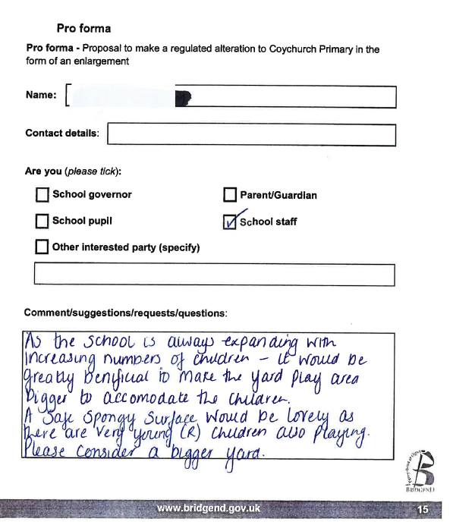

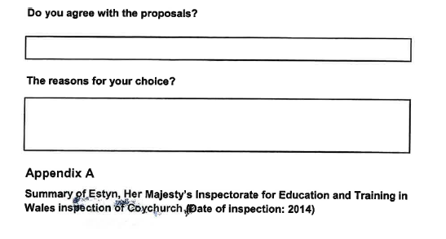
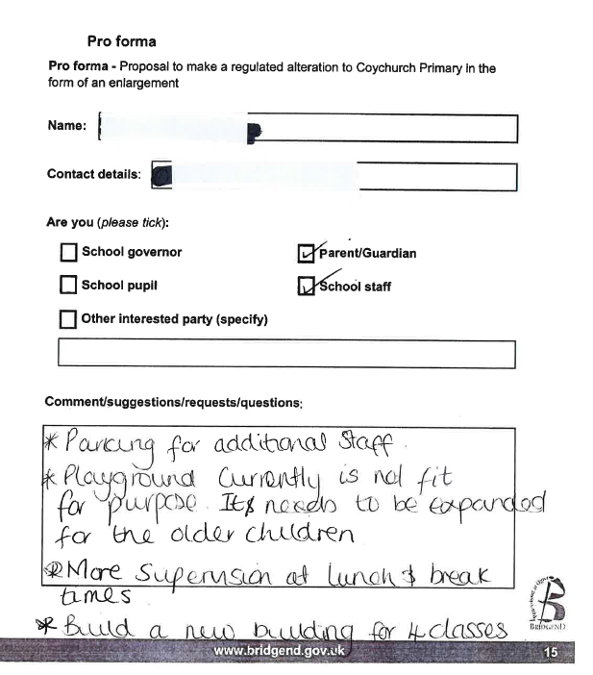

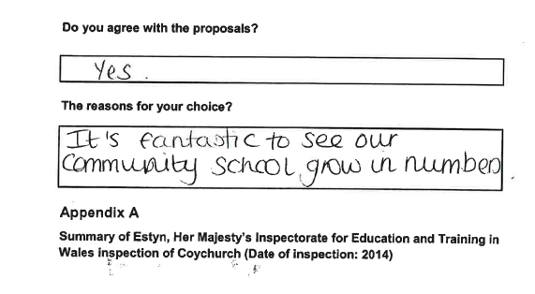
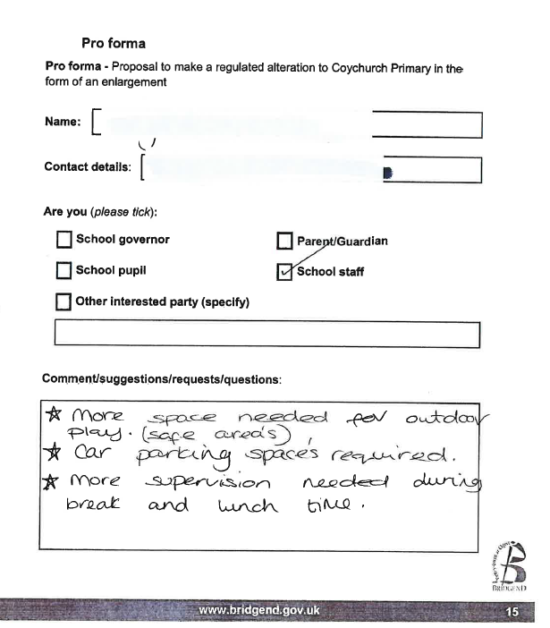

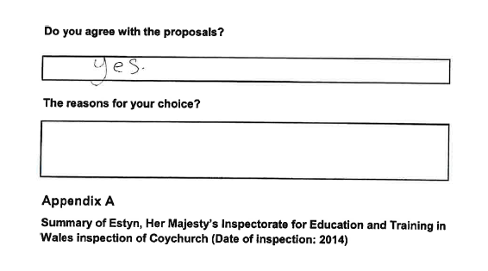
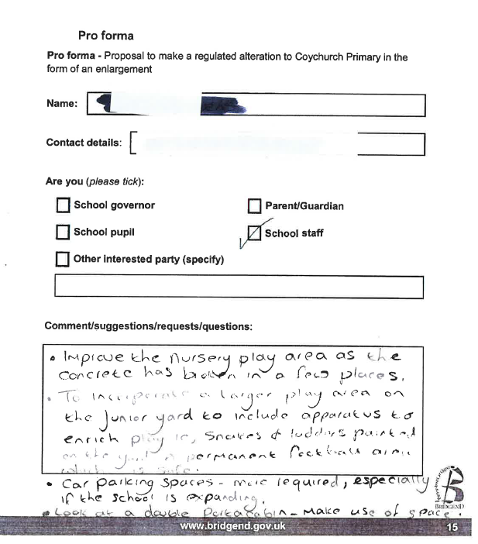

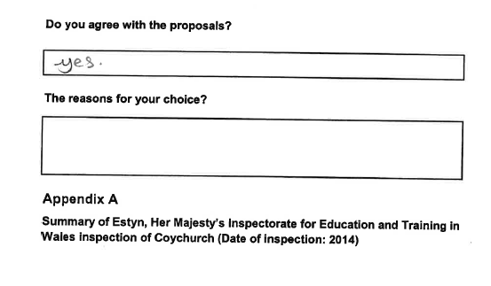
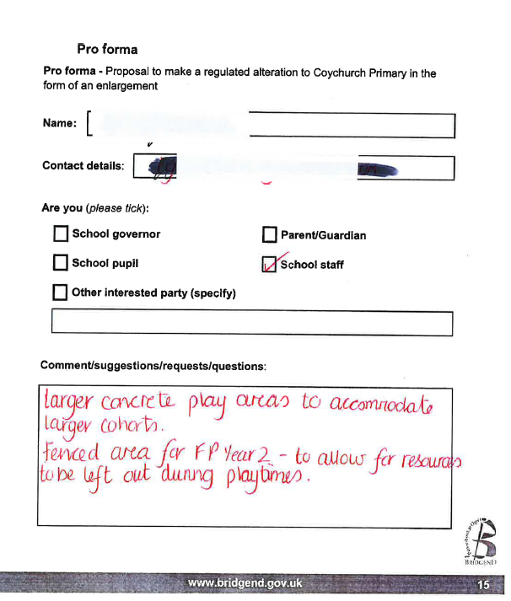

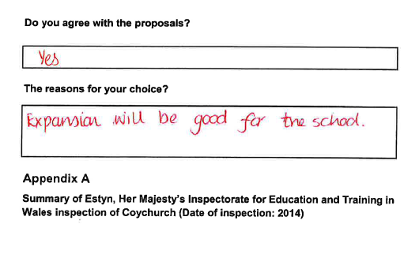
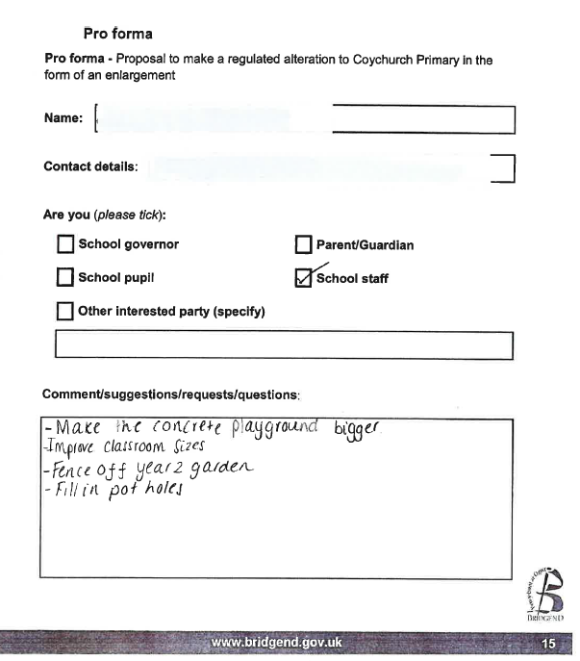

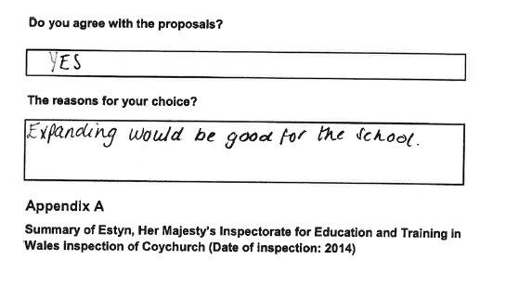
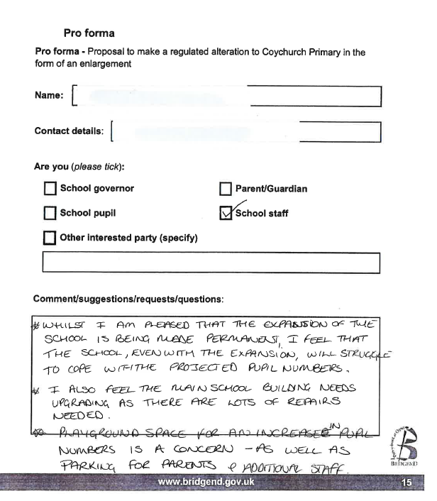

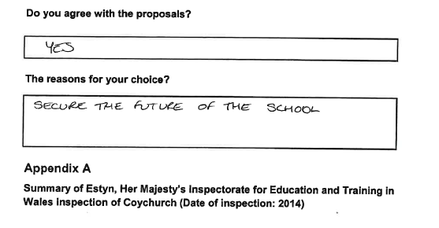

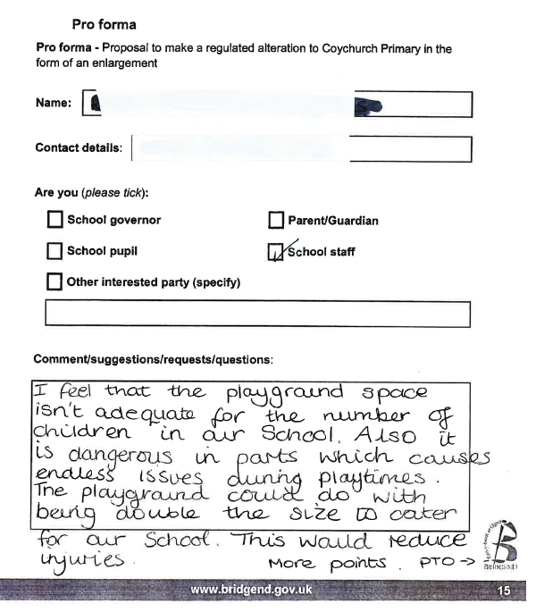
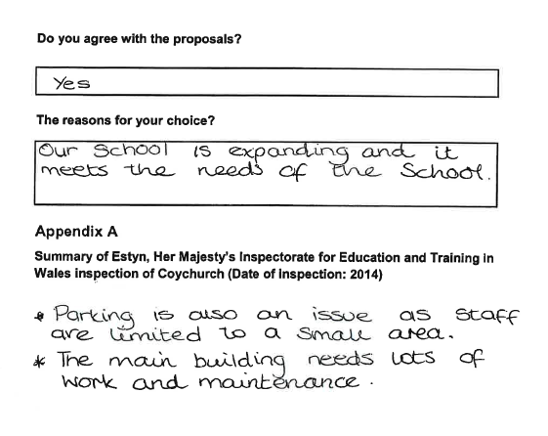
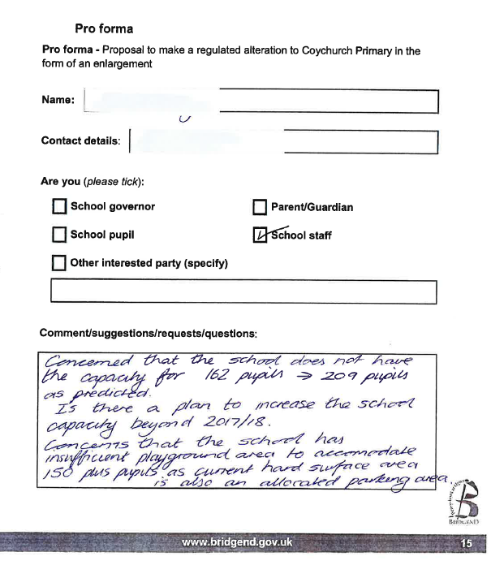
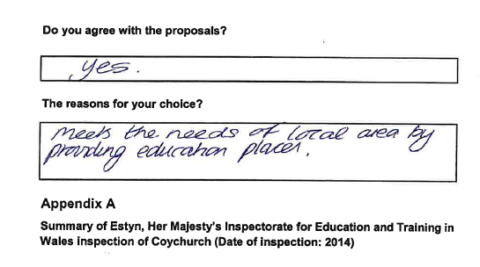
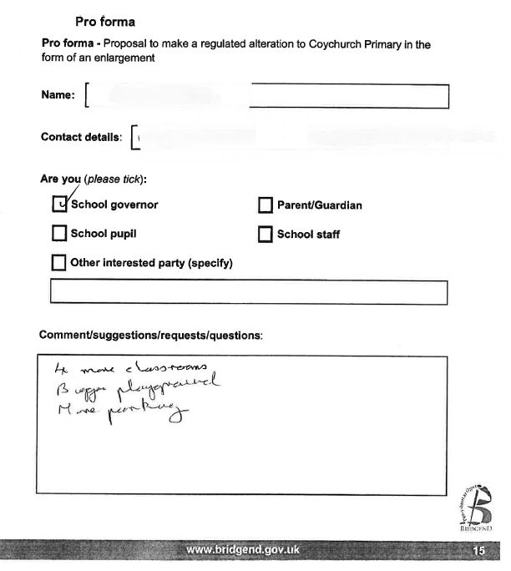

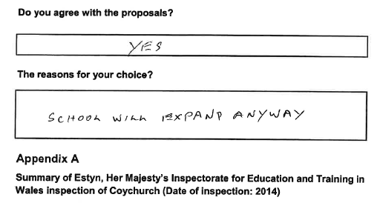
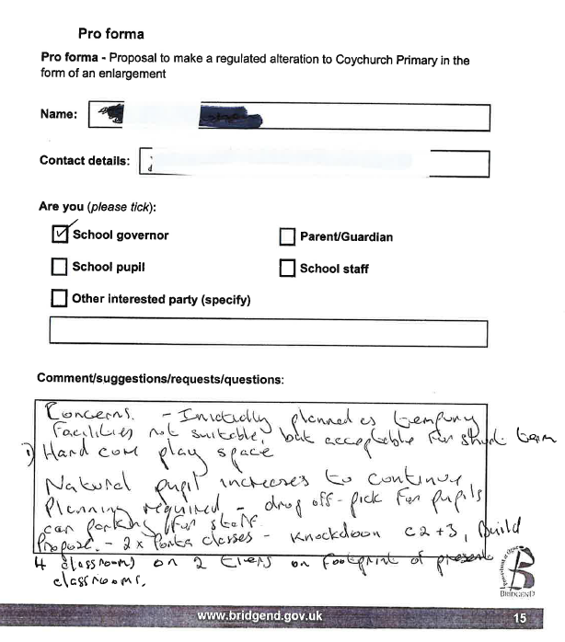

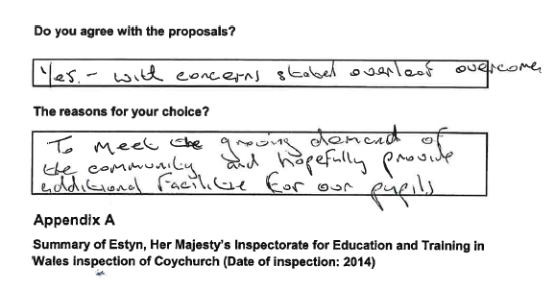
Appendix 8

Letters/Direct Correspondence
Subject: Response to Coychurch Primary expansion plans

Dear Ellen,

I am writing to you in response to the consultation to expand Coychurch Primary School, as outlined here: http://www.bridgend.gov.uk/media/461840/final-sc-cl-proposal-to-enlarge-coychurch-v1.docx

While I am supportive of the plans, I wish to express my concern at the projected pupil numbers for Coety Primary School for January 2025 outlined in for document.

It projects that there will be a surplus of 343 children in catchment for Coety with the caveat that this doesn't include numbers of children from new housing. This is almost double the number of children the school can take with its 400 capacity.

I am very concerned at educational provision for children in Coity and the surrounding areas as the new school is already oversubscribed. I don't feel the authority is planning adequately for education of children in the area especially considering the level of housebuilding going on in Parc Derwen and surrounding areas.

I hope my concerns will be expressed as part of the consultation report.

Regards,

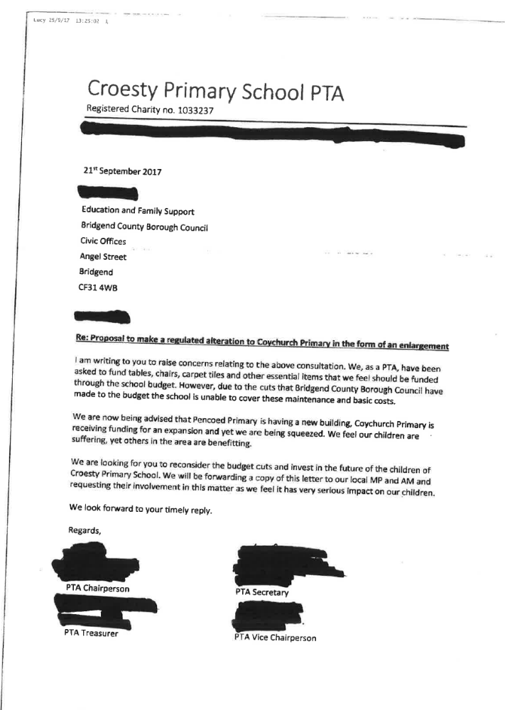

Appendix 9


