Bridgend County Borough Council

Bridgend Town Centre
Access survey
Consultation document

Date of issue: 8 August 2016
Action required: Responses by 24 October 2016

Tel: (01656) 643 664
Email: consultation@bridgend.gov.uk
Web: www.bridgend.gov.uk/consultation

www.bridgend.gov.uk

Contents
Overview 3
How to respond 3
Data protection 3
Related documents 3
Background and information 4
The proposal 4
Impact of the proposal 7
The consultation process 7
How to respond 7
Appendix 8

Overview
Bridgend County Borough Council has recently commissioned a study to review methods and assess risks of re-introducing traffic to Queen Street, Dunraven Place and Market Street in Bridgend town centre.
The council would like you to share your views on the proposal and the impact it would have on you and the wider economy.

How to respond
This consultation period will begin on the
8 August 2016 and close on the
24 October 2016.
You can respond or ask further questions in the following ways:
Tel: (01656) 643 664
Email: Consultation@bridgend.gov.uk
Online: Click here or visit www.bridgend.gov.uk/consultation
Post: Communications, Marketing and Engagement,
Bridgend County Borough Council, Raven’s Court, Wing 3, Brewery Lane, Bridgend, CF31 4AP.
Alternative formats are also available upon request.

Data protection
How we use the views and information you share with us.
All responses received by Bridgend County Borough Council will be seen in full by its staff members involved in the consultation process. The information may also be seen by other departments within the council or local service board members to help improve upon the services provided.
The council may also use the information gathered to publish subsequent documents both directly and indirectly linked to this consultation, however the council will never disclose any personal information such as names or addresses that could identify an individual.
If you do not wish for your opinions to be publicised, please state so in your response.

Related documents
- Commissioned report
For more information on consultations in Bridgend County Borough or how to join our Citizens’ panel.
Visit: www.bridgend.gov.uk/consultation

Background and information
In April 2016 Capita produced a report commissioned by Bridgend County Borough Council to review and risk assess ways to make the town centre more accessible for shoppers and visitors, as well as service vehicles with the aim to increase trade within the town. Town centre traders have reported significant reductions in footfall since the pedestrianisation scheme was completed in 2004 and more recently following the temporary closure of the Rhiw car park.
The commissioned report included four options to re-introduce traffic into the town centre:
Option one - introduce signage and road markings
Option two - introduce the measures in option 1 plus tactile paving
Option three - introduce the measures in option 1 and 2 plus bollards and street furniture
Option four - introduce the measures in option 1, 2 and 3 plus raised kerbs
Both option one and two failed to meet the council's safety obligations and as such were discounted. Option three was the suggested option in the independent report, whilst option four would cost the most to implement (approximately £855,000) and cause the highest level of disturbance to the town centre. As such, the council proposes that any work undertaken would follow option three as the preferred option.

The proposal
The proposal put forward is to reintroduce traffic to Queen Street, Dunraven Place and Market Street. As part of the proposal a 20 miles per hour speed zone and two pedestrian crossings would be introduced alongside approximately 18 parking / loading bays and street bollards designed to improve safety by separating pedestrians and vehicles. Adare Street and Caroline Street would remain pedestrianised.
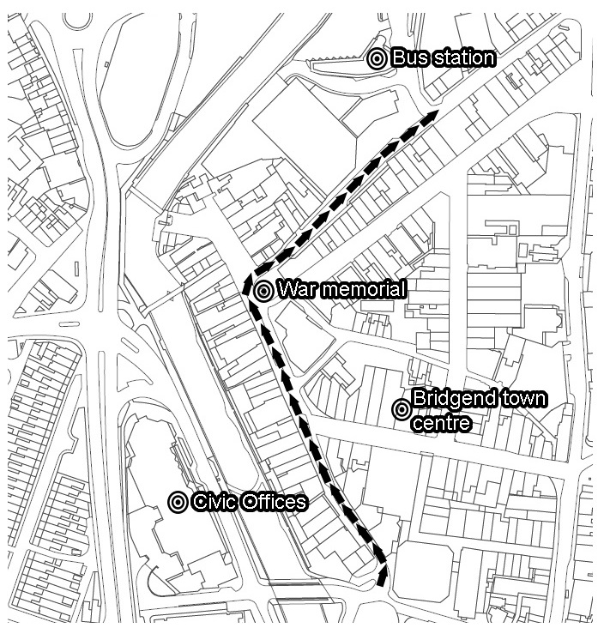
If the proposal were to be introduced the following risks and benefits would be likely to occur:

Benefits
- Easily accessibility
Improving vehicle access would prove beneficial for some disabled people and those with mobility problems.
- Potential to stimulate trade
Many town centre traders, property agents and developers believe that improving vehicle access into the town centre would stimulate the economic performance of the town by increasing footfall through car borne trade, short stay parking, click and collect, collection of large goods and short trips to banks and services.
- Potential to meet shoppers’ diverse needs
Meeting the needs of a diverse society by offering a balance between maintaining pedestriansation in Adare St. and Caroline St. and the proposed vehicle route.

Risks
- Increased risk to pedestrian safety
If the roads were to be reopened there would be an increased risk to pedestrian safety, in particular young children, the elderly and the blind community. Since pedestrianisation of the roads, reported collisions have fallen from 13 (2000 - 2004) to three (2004 - 2014).
- Investment cost
In order to safely allow vehicle access into the town centre an investment ranging between £500,000 and £900,000* would be required (dependent on the consultation's outcome) prior to any potential benefits being realised.
*Option one and two from the commissioned report failed to meet the council's safety obligations and as such were discounted.
- Air pollution
By allowing vehicle access into the town centre the level of air pollution will rise.

Pedestrian times
If the proposal were to be introduced, it is also possible to include 'pedestrian only' times. This has been introduced in other areas such as Neath, Caldicot and Tenby, where the roads are not accessible to vehicles between certain hours.
In relation to the second option below, if the roads were to be opened up to vehicles at night it would lead to better access to the night time economy but would also create an additional risk to pedestrians visiting the town at night.

Impact of the proposal
An initial Equality Impact Assessment (EIA) screening will be completed ready for when the consultation is live and will be reviewed following conclusion of this consultation (appendix 1.0).

The consultation process
Projected timetable for procedure and proposal implementation
Activity | Date
Response deadline | 24 October 2016
Final report published | 4 January 2017
Report to Cabinet on the outcomes of the consultation | 10 January 2017
Potential implementation | 1 April 2017

The outcomes of the consultation (which will be incorporated into the proposal to the report where possible) will be reported to the Cabinet of Bridgend County Borough Council. If there is a decision not to proceed, that will be the end of this proposal and an alternative proposal may be sought.
If any of the proposals are accepted by Cabinet the earliest the change(s) will come into effect is 1 April 2017.
How to respond
This consultation period will begin on the 8 August 2016 and close on the 24 October 2016. You can respond or ask further questions in the following ways:
Post: Communications, Marketing and Engagement,  Bridgend County Borough Council,  Raven’s Court, Wing 3,  Brewery Lane, Bridgend, CF31 4AP | Tel: (01656) 643 664  Email: Consultation@bridgend.gov.uk  Online: click here or visit www.bridgend.gov.uk/consultation
Alternative formats are also available upon request.

Appendix
Appendix 1.0 - Equality Impact Assessments (EIA).
Initial screening.
Full EIA to be completed after 24 October 2016.

