GUIDANCE NOTES W.C.A. 4  APPLICATION FOR A MODIFICATION ORDER TO  VARY A STATEMENT FOR A PUBLIC RIGHT OF WAY  Wildlife and Countryside (Definitive Maps and Statement) Regulations 1993 | 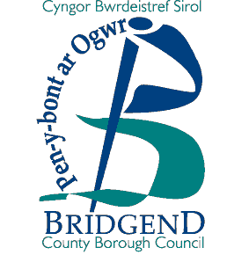
How to apply for a Modification Order to vary the statement for a public right of way.

- Please quote the right of way number from the Definitive Map, and provide an O.S. six figure map reference.

Please give details of the current Statement with the Definitive Map. Also give details of the proposed amended statement being the subject of the application.

COMPLETE OPTION 4 ON FORM W.C.A. 5

Documentary Evidence required:

  - map, not less than 1: 10,000 (6” to 1 mile).

  - any evidence considered relevant e.g. photographs, old maps, sworn statements
that the right of way has been used etc., in accordance with this claim.

- If the applicant is not the only owner and occupier of the land over which the right of way passes then all other owner(s) and occupier(s) must be notified (complete Option 4 on Form W.C.A. 6.

Form W.C.A. 6 must be sent to each owner and occupier affected by your application. If you cannot find every owner or occupier after making all reasonable efforts, you should send a letter with your completed application to the Council, giving full details of the steps you have taken.

- Complete Form W.C.A. 7, listing the landowner(s) and occupier(s) notified and return it with your application to:

Mr. Andrew Mason
Rights of Way Section
Communities Directorate
Bridgend County Borough Council
Waterton Lane
Waterton
Bridgend
CF31 3YP

