FORM W.C.A. 6  FORM OF NOTICE OF APPLICATION FOR A MODIFICATION ORDER  Wildlife and Countryside Act 1981 S. 53 (5)  Wildlife and Countryside (Definitive Maps and Statement) Regulations 1993 (Schedule 8) | 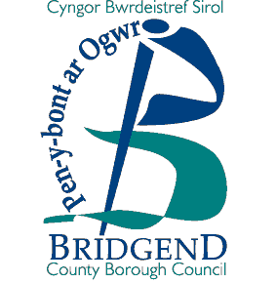
Bridgend County Borough Council Definitive Map and Statement

Community Of______________________________________________________________

To:________________________________________________________________________________

Of:________________________________________________________________________

I / We* (Name of Applicant)__________________________________________________________

Of (Address of Applicant)____________________________________________________________

hereby give notice that on (date) _____________________________________________________

I / we made application to Bridgend County Borough Council, that the Definitive Map and Statement for the area be modified by (* Please delete as appropriate):
OPTION 1: Deleting the *(footpath) *(bridleway) *(restricted byway) *(by-way open to all traffic)

shown as number______________________________________________________

leading from__________________________________________________________

to__________________________________________________________________

OPTION 2: Adding the *(footpath) *(bridleway) *(restricted byway)

leading from_________________________________________________________

to_________________________________________________________________

OPTION 3: *(Upgrading) / *(Downgrading) to a *(footpath) *(bridleway) *(restricted byway) the *(footpath) *(bridleway) *(restricted byway) *(byway open to all traffic)

shown as number______________________________________________________

leading from___________________________________________________________

to___________________________________________________________________

OPTION 4: *(Varying) / *(adding to) the statement particulars relating to the *(footpath) *(bridleway) *( restricted byway) *(by-way open to all traffic)

shown as number_______________________________________________________

leading from___________________________________________________________

to___________________________________________________________________

by providing that (please state the modification required) _______________________
____________________________________________________________________
____________________________________________________________________

Dated______________________________ Signed______________________________

Explanatory Note to Landowner
You will have received this notice as the applicant stated on the previous page has made an application to Bridgend County Borough Council to modify the Definitive Map and Statement as detailed above, and has identified you as a possible landowner affected. The County Borough Council will be in contact with you in due course when it commences its investigations in to the application for any comments you may have. In the meantime if you have any questions please contact the County Borough Council Rights of Way Section either by telephone on 642537/642595, by email to rightsofway@bridgend.gov.uk, or in writing to the following address:-

Rights of Way Section
Communities Directorate
Bridgend County Borough Council
Waterton Lane
Waterton
Bridgend
CF31 3YP

