NOTES AND APPLICATION FORMS FOR A  MODIFICATION ORDER  Wildlife and Countryside Act 1981  Wildlife and Countryside (Definitive Maps and Statements) Regulations 1993 | 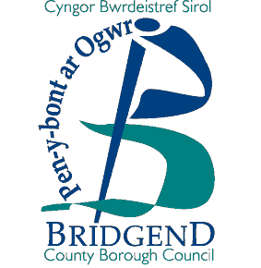
Notes for Applicants

- Deletion of a public right of way.
Read Guidance Notes W.C.A. 1 and complete forms W.C.A 5, 6 and 7 as appropriate

- Claimed new public right of way.
Read Guidance Notes W.C.A. 2 and complete forms W.C.A 5, 6 and 7 as appropriate

- Up/downgrading of a public right of way.
Read Guidance Notes W.C.A. 3 and complete forms W.C.A 5, 6 and 7 as appropriate

- Variation to the statement for a public right of way.
Read Guidance Notes W.C.A. 4 and complete forms W.C.A 5, 6 and 7 as appropriate

It is recommended that maps to accompany applications for Definitive Map Orders are based on Ordnance Survey maps, copies of which are available from all normal retail outlets and Ordnance Survey agents. Regrettably, the County Borough Council is unable to supply copies of maps for use with applications for Definitive Map Orders.

Completed forms to be returned to:

Mr. Andrew Mason
Rights of Way Section
Communities Directorate
Bridgend County Borough Council
Waterton Lane
Waterton
Bridgend
CF31 3YP

