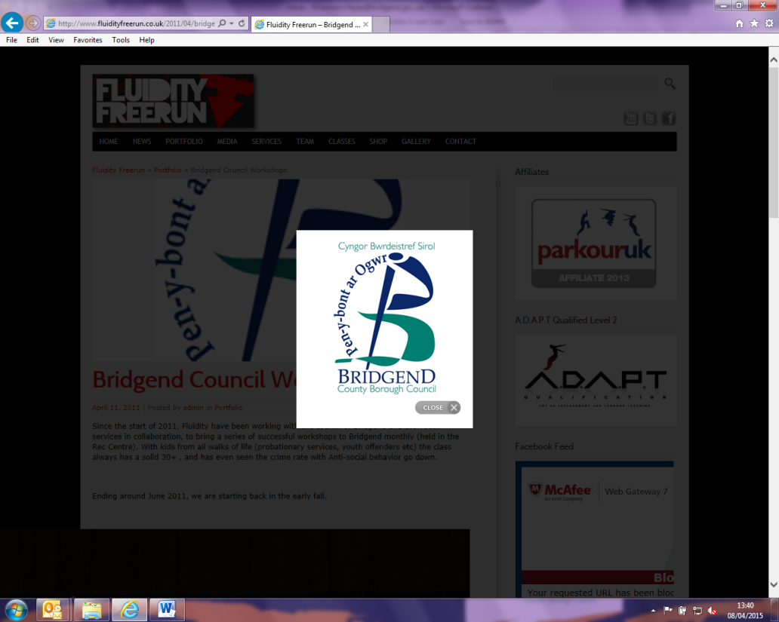

**EARLY YEARS AND YOUNG PEOPLE SUPPORT SERVICES REFERRAL FORM**

**Please send completed forms to** [**EarlyYearsandYoungPeople@bridgend.gov.uk**](mailto:EarlyYearsandYoungPeople@bridgend.gov.uk)

**Consent**

***Early Years and Young People Support Services are voluntary - any referral submitted without parental consent will not be accepted.***

**Do you have consent from the parent/carer to submit this referral?**

YES  NO

**Identified needs (select all that apply):**

|  |  |  |  |  |  |
| --- | --- | --- | --- | --- | --- |
| Self-esteem/confidence |  | Gender identity support |  | Attachment disorder |  |
| Anger management |  | Transition (school to college) |  | Motivation |  |
| Social skills |  | Personal safety |  | Independent living skills |  |
| Isolation |  | Travel training |  | Coping strategies |  |
| Anxiety/stress/low mood management |  | Persistent absence |  | Employment skills |  |
| Housing |  | Early language development and play skills |  | Wellbeing |  |
| Exploitation |  | Access to childcare |  | Other, please specify |  |

**Identified service area (select all that apply):**

|  |  |  |  |
| --- | --- | --- | --- |
| Family Engagement Officer |  | Health and Wellbeing Team |  |
| School Based Counselling |  | Early Years and Childcare |  |
| Community Counselling |  | Basic Skills |  |
| Inspire to Achieve + |  | Language and Play |  |
| Prevention of Youth Homelessness Team |  | Inspire to Work + |  |
| Youth Emotional Health Team |  | Other/not known |  |

**For child protection referrals please complete MASH referral form and send to:** [Mashcentra@bridgend.gov.uk](mailto:Mashcentra@bridgend.gov.uk)

**Date of referral:** Click or tap to enter a date.

1. **Details of person completing request:**

|  |  |
| --- | --- |
| Name: | Email: |
| Agency/designation: | Telephone: |

1. **Family/young person contact details:**

|  |  |
| --- | --- |
| Referred child: |  |
| Home address: |  |
| Telephone: |  |
| Email: |  |

1. **Family details** – please provide details of all relevant family members:

|  |  |  |  |  |  |
| --- | --- | --- | --- | --- | --- |
| Name | Live in household (Y/N)  (if no - please provide details below) | Name of nursery/ school/college | Relationship to child(children) referred | Date of birth | Gender |
|  |  |  |  |  |  |
|  |  |  |  |  |  |
|  |  |  |  |  |  |
|  |  |  |  |  |  |
|  |  |  |  |  |  |
|  |  |  |  |  |  |

*(Tab down to increase rows)*

**Please provide any additional family member details in the space below (for example address if not living within household)**

|  |
| --- |
|  |

1. **Family disabilities:**

**Are there any additional needs relating to disability within the family**  YES NO

**How many individuals within the family have additional needs relating to disability** Choose an item.

**Is any family member deaf and/or blind?** YES NO

**If you have answered yes to any of the questions relating to disability, please provide full details below:**

|  |
| --- |
|  |

1. **Agency involvement**

**Is the family currently open to Children’s Social Care?** YES NO

**Is the family currently open to any other services?** YES NO

|  |
| --- |
| If yes, please list all services in the box below |
|  |

1. **Why do you consider the requested intervention is needed for this child/young person/family?**

|  |
| --- |
| What are the worries for this child/young person/family? What has happened or what have you seen that has made you worried about this child / young person (past and current worries)? |
|  |

|  |
| --- |
| What’s going well for the child/young person/family? For example, positive adult relationships (family, school, community), peer friendships, engaged in learning, interests, hopes, ambitions, positive outlook and sense of self, good problem solver. |
|  |

|  |
| --- |
| What additional help do you consider this child/young person/family needs to effect change? |
|  |

**7. Risk assessment**

**Are there any known risks relating to any person connected with this referral?** YES NO

|  |
| --- |
| If yes to any of the above please provide full details (for example threats towards staff, history of domestic violence, substance misuse, exploitation) |
|  |